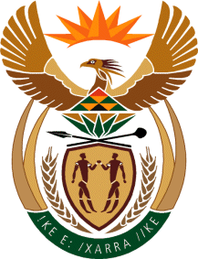

MINISTRY: COMMUNICATIONS
REPUBLIC OF SOUTH AFRICA
Private Bag X 745, Pretoria, 0001, Tel: +27 12 473 0164 Fax: +27 12 473 0585
Tshedimosetso House,1035 Francis Baard Street, Tshedimosetso House, Pretoria, 1000

NATIONAL ASSEMBLY
QUESTION FOR WRITTEN REPLY
QUESTION NUMBER: 1626
DATE OF PUBLICATION: MAY 2016

Ms P T van Damme (DA) to ask the Minister of Communications:

Whether the SA Broadcasting Corporation owes any (a) actors and/or (b) musicians any royalties; if so, what is (i) the name of each person owed, (ii) the amount owed to each specified person and (iii) by when will the outstanding royalties be paid in each case? NW1796E

REPLY: THE MINISTER OF COMMUNICATIONS

The payment of royalties to individual artists are managed by the collecting agencies/societies SAMRO, SAMPRA, AIRCO, IMPRA, RISA, CAPASSO. Therefore, the SABC does not pay Royalties to individual artists but to collecting Societies.

MR NN MUNZHELELE
DIRECTOR GENERAL [ACTING]
DEPARTMENT OF COMMUNICATIONS
DATE:

MS AF MUTHAMBI (MP)
MINISTER OF COMMUNICATIONS
DATE:

