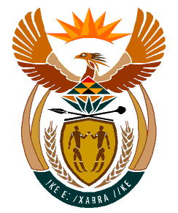

MINISTRY:
HUMAN SETTLEMENTS, WATER AND SANITATION
REPUBLIC OF SOUTH AFRICA

NATIONAL ASSEMBLY

QUESTION FOR WRITTEN REPLY

QUESTION NO.: 1625

DATE OF PUBLICATION: 22 NOVEMBER 2019

Mr L J Basson (DA) to ask the Minister of Human Settlements, Water and Sanitation:
Whether the Department of Water and Sanitation is currently building and/or planning to build houses for officials of the department in the North West province; if not, what is the position in this regard; if so, (a) where, (b) why, (c) what number and (d) at what cost will each house be built? NW2981E

REPLY:

- The Department of Water and Sanitation is currently not building or planning to build houses for officials of the department in the North West. It should be noted that in the course of preparing for construction of dams or water treatment plants, and as part of the broader project, a few houses are built to accommodate maintenance staff. However, I have been advised that there is no major construction project that is currently underway in the North West Province, where the Department of Water and Sanitation is building houses for this purpose.

- Falls away.

- Falls away.

- Falls away.

