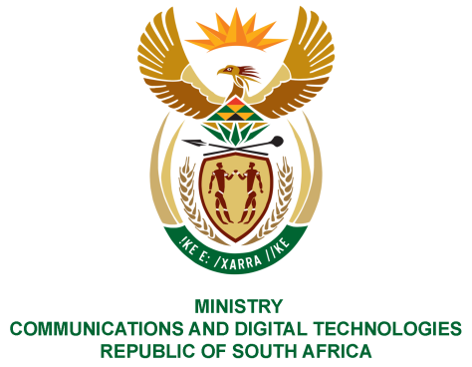
PARLIAMENTOF THE REPUBLIC OF SOUTH AFRICA
NATIONAL ASSEMBLY
WRITTEN REPLY

QUESTION NO: 1624
DATE OF PUBLICATION: 17 July 2020
QUESTION PAPER NO: 26

Ms PT van Damme (DA) to ask the Minister of Communications:

What (a) are the reasons for the cancellation by the Universal Service and Access Agency of South Africa (USAASA) of the tender for the appointment of a panel of suppliers for the procurement of 32-inch Integrated Digital Television (IDTVs) for indigent 2020 matriculants, (b) total amount was budgeted to purchase the IDTVs and (c) number of IDTVs did USAASA intend to procure? NW2008E

REPLY
I have been advised by the USAASA as follows:

- Tender USAF – IDTV/01/2020 was a multifaceted tender which was divided into Part A (establishment of a database of suppliers to supply 32 Inch IDTV’s for indigent households with matric learners) and Part B (establishment of a database of suppliers to supply 32 Inch IDTV’s for the BDM Phase 2 roll out).This tender was cancelled for two reasons; namely (i)localisation and local production was not clearly defined in the initial tender which has major economic consequences for South Africa; (ii) the tender needed to be split into two (2) separate tenders to ease the evaluation and adjudication of the tenders and administration thereof.

The two separated tenders were re-advertised on 12 June 2020 with closing date of 2 July 2020 in the Tender Bulletin with the Tender Numbers (i)USAF-IDTV/02/2020 and (ii) USAF- IDTV/03/2020. USAASA indicated they are at the Bid Evaluation stage to appoint suppliers for the 32 inch IDTV, it is envisaged that the Adjudication will be done in September 2020 and thereafter the distribution of the IDTVs will take effect.

- The procurement of IDTV’s for indigent households with matric learners is a Covid- 19 initiative which was not budgeted for. However, National Treasury was approached to approve utilising accumulated interest to the amount of R242 million.
- USAASA is working closely with seven (7) provincial Departments of Basic Education to collect information regarding indigent households with matric learners. The final numbers of indigent households with matric learners are not yet finalised. The total number of IDTV’s to be procured will be for the total amount of R242 million, at a market price.

MS. STELLA NDABENI-ABRAHAMS, MP
MINISTER OF COMMUNICATIONS AND DIGITAL TECHNOLOGIES

