NATIONAL ASSEMBLY

FOR WRITTEN REPLY

QUESTION NO. 1622

DATE OF PUBLICATION IN INTERNAL QUESTION PAPER: 25 MAY 2018
(INTERNAL QUESTION PAPER NO. 18)

Ms S P Kopane (DA) to ask the Minister of Health:
(1) What (a)(i) are the details of the methodology used by his department to assess the 3 400 public healthcare facilities to determine their functionality, (ii) is the total number of assessors who were involved, (b) criteria were used to identify each facility and (c) are the details of the outcome of the assessment;
(2) whether any consultants were used to conduct the assessment; if not, why not; if so, what are the relevant details?

NW1772E
REPLY:

- (a) (i) The functionality of the 3480 public health facilities are assessed using the Ideal Clinic Realisation and Maintenance Tool developed by the department of health as part of the Operation Phakisa Ideal Clinic Laboratory. In preparation for the introduction of National Health Insurance (NHI), the Ideal Clinic programme is setting in place a systematic approach to transform all PHC facilities to meet national standards when inspected by the Office of Health Standards Compliance (OHSC). The National Health Amendment Act (12 of 2013) mandates the OHSC to protect and promote the health and safety of health service users through monitoring and enforcing compliance with prescribed norms and standards. The Ideal Clinic programme is the NDoH’s internal mechanism for ensuring PHC facilities’ compliance with these norms and standards in order to satisfy the needs of South African communities.
A dashboard, using the standard traffic-light colours, was developed. The figure below depicts the arrangement of 32 sub-components under 10 components. The 32 sub-components are further subdivided into 206 elements. The number of elements change on an annual basis as the national team receive feedback from clinical staff and managers on clinic and district level about how to improve the framework. Elements are assigned a green colour when they are fully functional, an orange colour if they are partially functional and corrective actions are under way, and a red colour if the element is absent or non-functional.

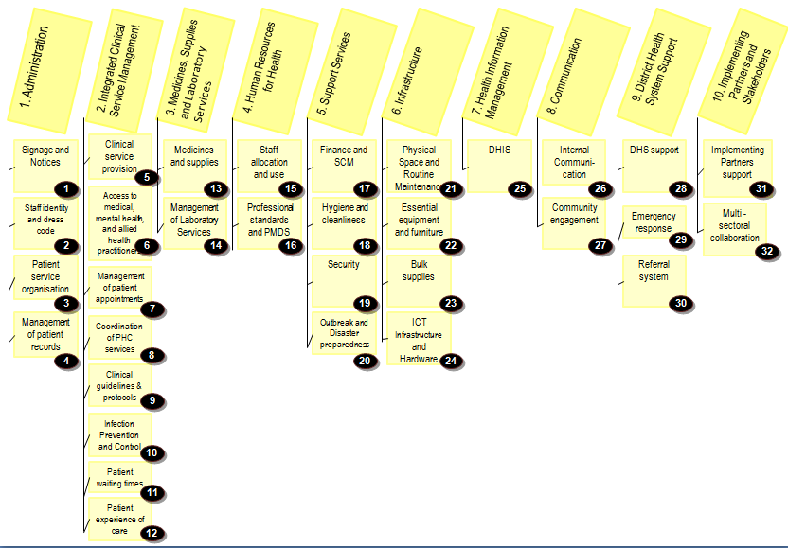

The elements are assigned a vital, essential or important weight in line with the definitions below.

The table below indicates the scores required per element weight.

Weights | Silver | Gold | Platinum
Vital  (10 elements) | 90% | 100% | 100%
Essential  (86 elements) | 70% | 80% | 90%
Important  (110 elements) | 68% | 78% | 89%
AVERAGE | 70%-79% | 80%-89% | 90%-100%
The Ideal Clinic Realisation and Maintenance (ICRM) Programme follows the PLAN, DO STUDY, Act (PDSA) cycle. The first large scale planning took place in October and November 2014. This in-depth planning in a laboratory setting called “Operation Phakisa Ideal Clinic Lab” resulted in a comprehensive implementation plan. The cycle starts with status determinations by PHC facility managers(April to June) and a re-planning session in May. This is followed by the correction of weaknesses (turning red and orange elements green during July to October). In November district peer reviews are done.
Peer review results are immediately captured on the web based ICRM monitoring software tool for the purpose of result analyses (Study). District scale-up teams then assist clinic managers and staff to turn the remaining orange and red elements to green (December to February). In March peer review updates are done to determine achievement for the financial year. The NDoH receives continuous feedback from managers and staff at provincial, district and facility level about changes required to guidelines, standard operating procedures and systems processes that currently cause bottlenecks. The results are used to plan the implementation for the next year. Planning for the following year includes amendments to the framework resulting in a subsequent version.

(ii) Professionals who do the status determinations through peer reviews are from South Africa's 52 health districts. Every year, since the implementation of the programme, 196 professionals are orientated to do the peer reviews.
(b) In the beginning of each financial year since 2015/2016 to date all fixed primary health care facilities in the country are subjected to status determination (assessment) exercise;

(c) The details of the outcome of the assessment from 2015/2016 to 2017/2018 is as follows
District/ Metro | Total Facilities | 2015/16 Ideal Clinics | 2016/17 Ideal Clinics | No clinics from 2015 to 2017 that remained Ideal in 2017/18 | 2017/18 Ideal Clinics | Total Ideal Clinics | % Ideal Clinics
Eastern Cape | 771 | 14 | 128 | 93 | 64 | 157 | 20.4
Free State | 221 | 22 | 49 | 75 | 39 | 114 | 51.6
Gauteng | 367 | 89 | 133 | 200 | 91 | 291 | 79.3
KwaZulu-Natal | 600 | 141 | 204 | 303 | 80 | 383 | 63.8
Limpopo | 477 | 27 | 42 | 49 | 72 | 121 | 25.4
Mpumalanga | 288 | 19 | 46 | 46 | 41 | 87 | 30.2
North West | 314 | 7 | 86 | 75 | 46 | 121 | 38.5
Northern Cape | 164 | 3 | 62 | 58 | 31 | 89 | 54.3
Western Cape | 275 |  | 36 | 34 | 110 | 144 | 52.4
South Africa | 3,477 | 322 | 786 | 933 | 574 | 1507 | 43.3
(2) The department does not use consultants for this task. District quality assurance and supervisory staff are formed into a team to do peer reviews.

END.

Republic of South Africa.National Health Amendment Act (12 of 2013). Cape Town: Government Gazette No. 367, 24 July 2013.

