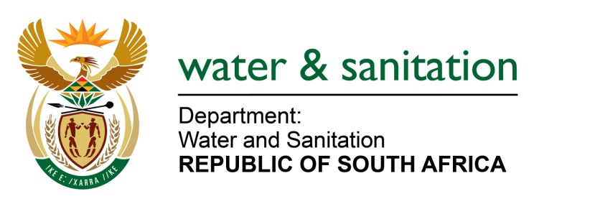

NATIONAL ASSEMBLY

FOR WRITTEN REPLY

QUESTION NO 1619

DATE OF PUBLICATION IN INTERNAL QUESTION PAPER: 12 MAY 2023
(INTERNAL QUESTION PAPER NO. 16)
1619. Mrs M R Mohlala (EFF) to ask the Minister of Water and Sanitation:
What (a) total number of directives have been issued against municipalities that fail to manage sewage and effluent polluting major water sources and (b)(i) is the breakdown of the directives issued in each province, (ii) are consequences thereof and (iii) follow-up assessments have been undertaken from 2021 up to the latest specified date for which information is available? NW1843E
---00O00---
MINISTER OF WATER AND SANITATION
- The Department of Water and Sanitation (DWS) has issued 83 directives from January 2021 to date against municipalities that have failed to manage sewage and causing pollution.

- (i) The table below depicts a breakdown of the directives issued per province.
Enforcement Actions taken against non-compliant Municipalities *from January 2021 to date
Responsible Regional Office | *NWA Notices Issued | NWA Directives Issued
Eastern Cape | 10 | 8
Free State | 6 | 7
Gauteng | 20 | 18
KwaZulu Natal | 21 | 1
Limpopo | 11 | 13
Mpumalanga | 39 | 22
North-West | 5 | 5
Northern Cape | 30 | 8
Western Cape | 12 | 1
Total | 154 | 83
- The consequences of DWS’ enforcement actions are indicated below:
- Five criminal charges laid against municipalities because of non-compliance with the Directives issued.
- Two criminal charges were laid and finalised against Randfontein and Thaba Chweu Local Municipality whereby both municipalities pleaded guilty of all the charges. Both municipalities were subsequently fined by the courts for failure to adhere to the provisions of NWA, among other violations.
- Three cases were referred to National Prosecuting Authority for a decision. The Department has initiated three court interdict applications against the non-compliant municipalities, seeking Court Orders from the courts.
(iii) The DWS conducted 49 follow-up inspections whereby compliance with the provisions of the Notices and Directives is established.
---00O00---

