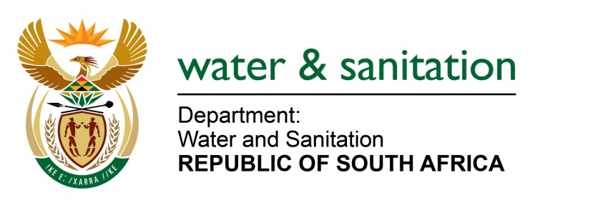

NATIONAL ASSEMBLY

FOR WRITTEN REPLY

QUESTION NO 1618

DATE OF PUBLICATION IN INTERNAL QUESTION PAPER:
(INTERNAL QUESTION PAPER NO. 16) 12 MAY 2023

1618. Mrs M R Mohlala (EFF) to ask the Minister of Water and Sanitation:
What actions has he taken in response to the reports that over 30 families in the Cato Crest informal settlement in Durban are forced to share just one pit toilet? NW1842E
---00O00---

MINISTER OF WATER AND SANITATION

The eThekwini Metropolitan Municipality has reported that it is providing communities the in Cato Crest informal areas with different types of sanitation services. In the informal settlement areas, the municipality is providing communities with Community Ablution Blocks (communal ablution facilities providing full waterborne sanitation) as well as portable chemical toilets in areas where CABs cannot be constructed due to there being no water borne wastewater infrastructure or when the relocation of families to formal housing structures is imminent.

Further to this, the eThekwini Metro has reported that the municipality is not aware of the 30 families that are sharing one pit toilet in the Cato Crest informal area. However, should the municipality be assisted to identify the families mentioned in the question, they can be assisted through the municipality’s existing programmes for sanitation services for informal settlements areas in the form of chemical toilets as a short-term intervention and Community Ablution Blocks as a medium-term solution that can be completed within a period of six months.

---00O00---

