NATIONAL ASSEMBLY

FOR WRITTEN REPLY

QUESTION NO. 1611

DATE OF PUBLICATION IN INTERNAL QUESTION PAPER: 12 MAY 2023
(INTERNAL QUESTION PAPER NO. 16)
Ms N N Chirwa (EFF) to ask the Minister of Health:
Noting how numerous facilities do not have floor plans and/or adequate fire detection systems in place, (a) what is the current status of healthcare facilities regarding this in each province, (b) what measures will he put in place to resolve the issue and (c) on what date will he ensure intervention with resolve is enacted? NW1822E
REPLY:

(a) (i) Floor plans are available for all our health care facilities. However, most of them are outdated due to the aging of many facilities. (ii) See below existing health facilities with adequate fire detection systems:

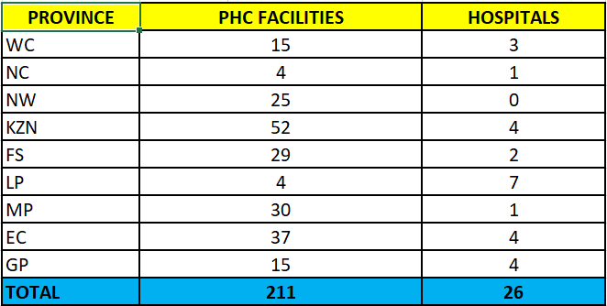

(b)-(c) Aging public health facilities remains a challenge and growing concern for the Department of Health. The short-, medium- and long-term focus is thus more on restoring many of these facilities to an acceptable state of operability. The National Department of Health is currently busy with the following interventions:

- CSIR is currently busy with an investigation into how to become more green in future and will include the OHS Compliance issues and fire detection systems for all the healthcare facilities.

- Provinces have been requested to include the update of the floor plans and fire detection systems during the condition assessment audits of their facilities. This request is aligned with the requirements of the Government Immovable Asset Management Act (GIAMA).

In the same Act the User, which in this case is the Provincial Departments of Health, should annually revise its User Asset Management Plan (UAMP) in alignment with the guidelines provided by Public Works. The User Immovable Asset Management Plan (UAMP) for the Department of Health informs the budget allocation process in terms of the overall and annual strategic plans of the Department. The objectives of the UAMP are to:

- assess the utilisation of accommodation in terms of the Department of Health’s service delivery objectives.
- assess the functional performance of the accommodation.
- prioritise the need for repair, refurbishment or reconfiguration of all state-owned accommodation.
- plan for future accommodation requirements and
- secure funding for the acquisition and utilisation of assets according to the strategic objectives of the relevant department.
- All major upgrades and new installations must cover the upgrading of the fire detection systems.

END.

