THE NATIONAL ASSEMBLY

QUESTION FOR WRITTEN REPLY

QUESTION NO. 1611

Mr M J Cuthbert (DA) to ask the Minister of Trade, Industry and Competition:
Whether he will provide Mr M J Cuthbert with a detailed list of all (a) logistics, (b) catering, (c) venue hire, (d) musician hire and (e) advertising terms of the budget spent for all National Lottery roadshows that took place in the 2019-20 financial year? [NW1995E]

REPLY

I have been furnished with a reply to the question submitted, by Ms Thabang Mampane, Commissioner of the National Lotteries Commission, which is reproduced below.

2019/20 Activities | Total Budget Spent
A summary of activities attached | - Logistics | R 5 723 997.37
 | - Catering | R 1 509 085.20
 | - Venue hire | R 879 758.42
 | - Music hire | R 65 000.00
 | - Advertising | R 2 612 647.75

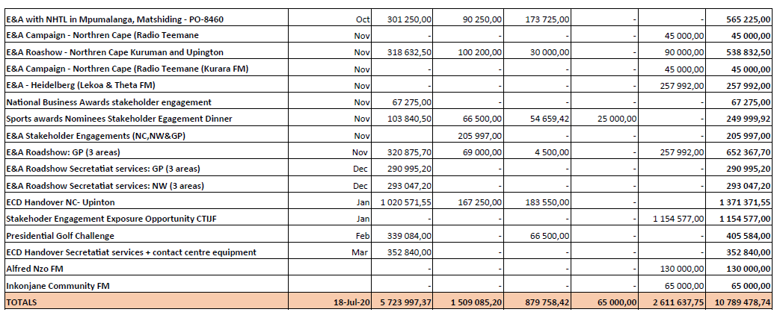
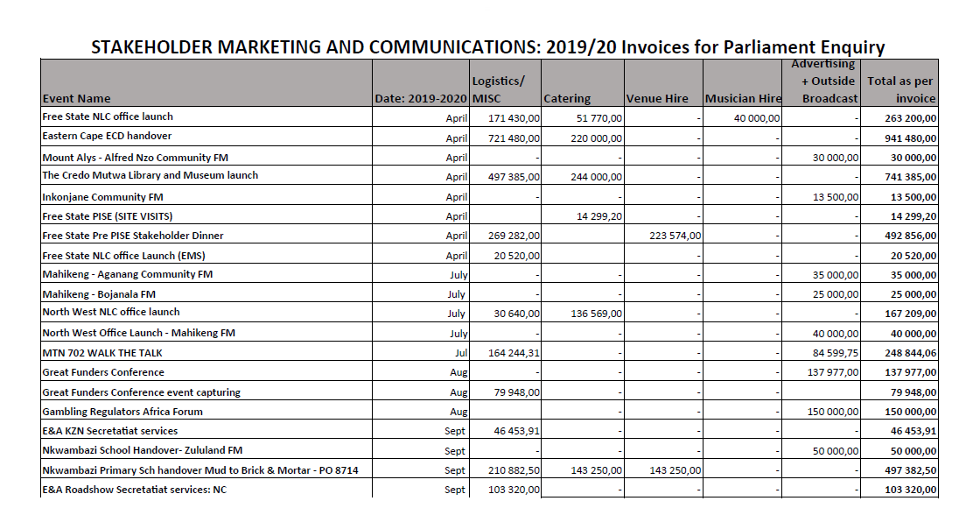

-END-

