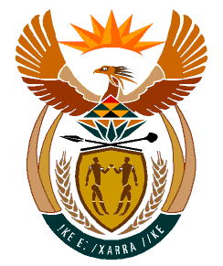

MINISTRY
HUMAN SETTLEMENTS
REPUBLIC OF SOUTH AFRICA

Private Bag X645, Pretoria, 0001. Tel: (012) 421 1309, Fax: (012) 341 8513

Private Bag X9029, Cape Town, 8000. Tel (021) 466 7603, Fax: (021) 466 3610

NATIONAL ASSEMBLY
QUESTION FOR WITTEN REPLY
QUESTION NUMBER: PQ 161 [NW165E]
DATE OF PUBLICATION: 11 FEBRUARY 2022

Mr G K Y Cachalia (DA) to ask the Minister of Human Settlements:

Whether she and/or her department ever received correspondence from a certain political organisation (details furnished), via email, WhatsApp, hardcopy and/or in any other format of which the original file is dated June 2020; if not, what is the position in this regard; if so, (a) on what date was the specified correspondence received, (b) who was the sender of the correspondence and (c) what steps were taken by her department in this regard? NW165E

REPLY:
No.

