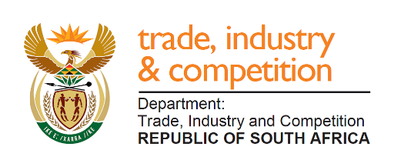

THE NATIONAL ASSEMBLY
QUESTION FOR WRITTEN REPLY

PARLIAMENTARY QUESTION 1603

Mr J W W Julius (DA) to ask the Minister of Trade and Industry:
(a) What amount did the National Empowerment Fund contribute towards land reform and agricultural projects in each year since 2016, (b) were the amounts in the form of loans and/or grants and (c) what is the success rate of the investment?W2959E
Reply:

I am advised that since 2016, the NEF has provided R60 million in funding to four companies in relation to agriculture or land reform projects. The NEF provides business funding as a combination of loans and equity and does not provide grant funding. A supplementary reply will be provided with additional information.

-END-

