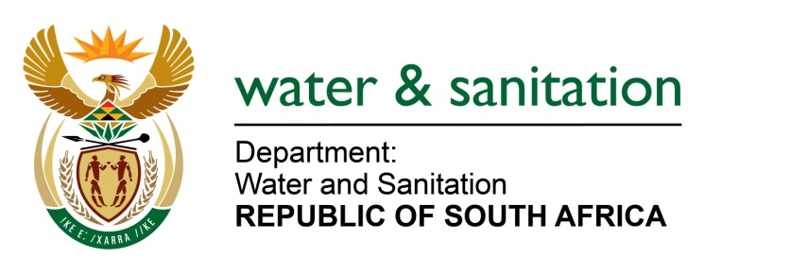

NATIONAL ASSEMBLY

FOR WRITTEN REPLY

QUESTION NO 1601

DATE OF PUBLICATION IN INTERNAL QUESTION PAPER: 9 JUNE 2017
(INTERNAL QUESTION PAPER NO. 21)

1601. Ms N V Mente (EFF) to ask the Minister of Water and Sanitation:
(a) What percentage of her department’s budget was allocated towards drought relief in the current financial year and (b) what amount was allocated for the Western Cape? NW1806E
---00O00---
REPLY:

(a) My Department does not have a budget allocation for drought relief in the 2017/18 financial year.

(b) There is no amount allocated for Western Cape towards drought relief in the 2017/18 financial year.

---00O00---

