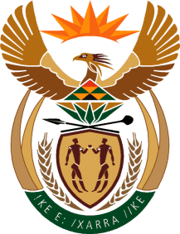

MINISTRY OF TOURISM
REPUBLIC OF SOUTH AFRICA

Private Bag X424, Pretoria, 0001, South Africa. Tel. (+27 12) 444 6780, Fax (+27 12) 444 7027
Private Bag X9154, Cape Town, 8000, South Africa. Tel. (+27 21) 469 5800, Fax: (+27 21) 465 3216

Ref: TM 2/1/1/10

NATIONAL ASSEMBLY:
QUESTION FOR WRITTEN REPLY:
Question Number: 1600
Date of Publication: 26 May 2018
NA IQP Number: 18
Date of reply: 14 June 2018

Mr D America (DA) to ask the Minister of Tourism:

In view of his department’s indication during meetings of the Portfolio Committee on Tourism that it would work with other government departments to look into the excessive aviation taxes, what (a) engagements has his department undertaken with other government departments thus far and (b) steps has his department taken to achieve the stated objective? NW1750E

Reply:
- The Department is a member of the National Transport Forum and engages on all matters affecting tourism. This includes recent engagements with all relevant departments in the Tourism Strategy Implementation Work-Stream focusing on facilitating ease of access broadly.

- The Department of Transport is also working on establishing the Single Transport Economic Regulator (STER) to consolidate the economic regulation of transport. The STER will, amongst others, promote transparency in the setting of transport fees and stakeholders will have a mechanism to provide their views. The Department of Tourism was engaged in respect of this process and provided its inputs.

- In the previous year, ACSA announced the reduction of airport fees by 35% from April 2017.
-Passenger service charge per departing domestic passenger: R82 (from R127)
-Passenger service charge per departing international passenger: R223 (from R346)
-Passenger service charge per departing passenger for an airport within Botswana, Namibia
and Swaziland: R169 (from R263)

- The 35% reduction in prices is in line with UNWTO’s calls for destinations to avoid stifling tourism growth with exorbitant charges.

