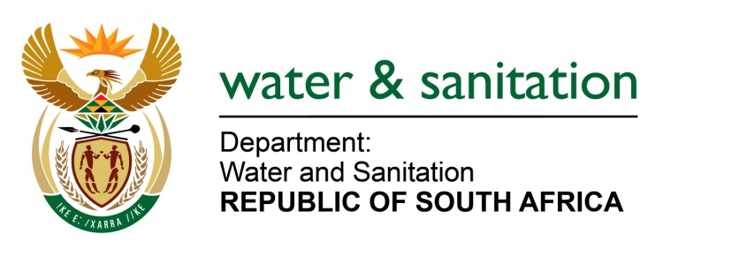

NATIONAL ASSEMBLY

FOR WRITTEN REPLY

QUESTION NO 1600

DATE OF PUBLICATION IN INTERNAL QUESTION PAPER: 9 JUNE 2017
(INTERNAL QUESTION PAPER NO. 21)

1600. Ms M S Khawula (EFF) to ask the Minister of Water and Sanitation:
Whether her department has any (a) partnership or (b) bilateral agreement with any government entity in Israel; if not, what is the position in this regard; if so, how many Israeli companies are involved in these (i) partnerships and (ii) agreements? NW1805E
---00O00---
REPLY:

No, my Department does not have any partnership or bilateral agreements with any government entity in Israel.

---00O00---

