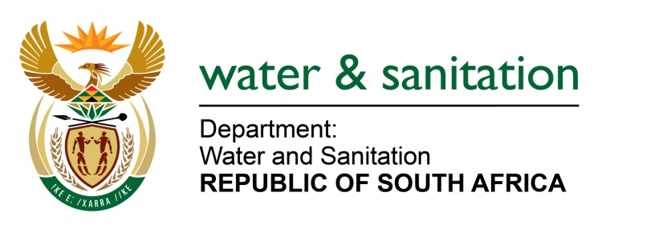

NATIONAL ASSEMBLY

FOR WRITTEN REPLY

QUESTION NO 1599

DATE OF PUBLICATION IN INTERNAL QUESTION PAPER: 9 JUNE 2017
(INTERNAL QUESTION PAPER NO. 21)

1599. Ms M S Khawula (EFF) to ask the Minister of Water and Sanitation:
Given South Africa’s water crisis and findings by the World Resources Institute that South Africa will be one of the world’s most water stressed countries by 2040, as compared to countries such as Somalia and Sudan, what is her department doing to promote innovation and development in the water saving sector, in terms of (a) money spent and (b) plan of action? NW1804E
---00O00---
REPLY:
(a) My Department is spending a budget of R1,2 Million in the financial year 2017/18 to promote development of innovation in water sector through programmes such as South African Youth Water Prize is a Science and Technology based project, facilitate installation of Water Administration System at the irrigation schemes and the use of Global System for Mobile (GSM) communication to enable electronic water measurement in the irrigation sector.
(b) The plan of action is to continue to enhance the research innovation development work my Department is doing. This further entails strengthening relationships with stakeholders and partners in the Water Sector such as Department of Science and Technology (DST), Water Research Commission (WRC), Agriculture Research Council and various organized Industry Sectors .i.e. Pulp and Paper Association, Food and Beverages Association and Chamber of Mines. My Department also plans to enhance the already existing innovations by hosting exhibitions in collaboration with WRC and DST. My Department is consistently uploading new innovations on the Departmental website to ensure dissemination of information in addition to national road shows and visiting of public schools as part of raising awareness.
Currently, what needs to be done in earnest is to encourage all water users in the Republic of South Africa) to use water sparingly and do everything within their means to stop leakages. In that regard, my Department is training youth in the War on Leaks programme to assist Municipalities in combating water losses.
---00O00---

