

**MINISTRY**

**STATE SECURITY**

**REPUBLIC OF SOUTH AFRICA**

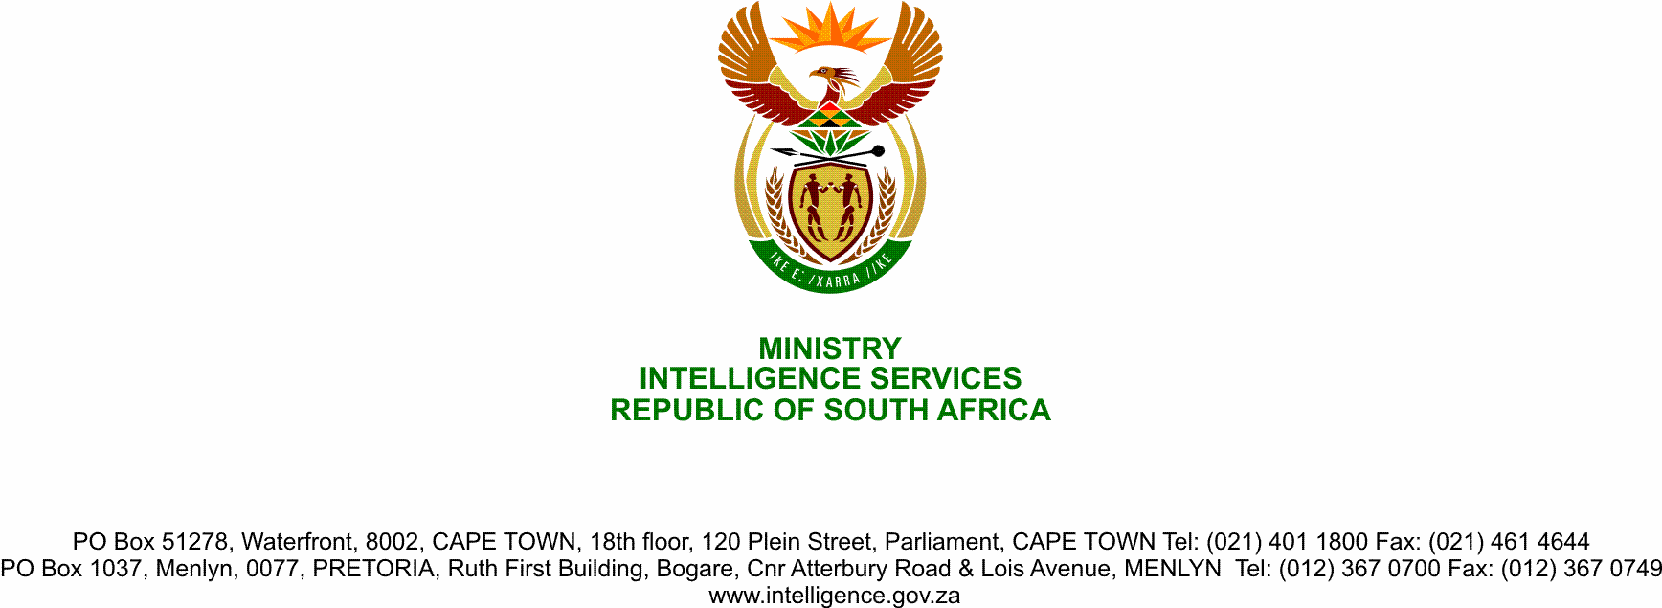

**NATIONAL ASSEMBLY**

**QUESTION FOR WRITTEN REPLY**

**QUESTION NO.: 1598.**

**Ms D Kohler (DA) to ask the Minister of State Security:**

(1) Whether she was asked in her official capacity as the Minister of State Security by the President of the Republic, Mr M C Ramaphosa, to discuss the legal matter between a certain person (name furnished) and the Republic of Botswana while planning to meet with the President of the Republic of Botswana, Mr M E K Masisi, at the beginning of July 2020; if not, what is the position in this regard; if so, (a) what are the relevant details, (b) how did she respond to the specified request and (c) on what statutory or any other grounds did she rely to accept the President’s request to intervene in a private matter;

(2) whether she has ever held any discussions in her official capacity as the Minister of State Security with President M E K Masisi regarding the allegations levelled against the specified person by the Republic of Botswana; if not, what is the position in this regard; if so, what are the relevant details;

(3) whether she has ever been asked in her official capacity as the Minister of State Security to intervene in the private matters of any of her colleagues; if not, what is the position in this regard; if so, (a) what are the relevant details and (b) on what statutory and/or any other grounds did she rely in order to intervene in the private matters of any of her colleagues;

(4) why did she cancel her planned visit to the Republic of Botswana at the beginning of July 2020;

(5) whether she intends to travel to the Republic of Botswana in the remainder of 2020 to discuss matters surrounding the (a) Southern African Customs Union and/or (b) allegations levelled against the said person; if not, in each case, why not; if so, what are the relevant details in each case? NW1982E

**REPLY**

(1) The Minister has never been asked by the President to intervene on the

matter in question.

Any legal matter between South Africa and any other country would be dealt with through the appropriate channels and instruments, such as mutual legal assistance. The Ministry responsible for the Civilian Intelligence structures is not one of such instruments.

(2) There has never been a discussion between the President of Botswana and

the Minister on this matter.

(3) None.

(4) The visit was cancelled because of other commitments.

(5) Purpose for which the visit was intended remains valid, therefore, a visit in the near future cannot be rulled out.