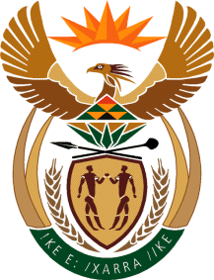

MINISTRY OF TOURISM
REPUBLIC OF SOUTH AFRICA

Private Bag X424, Pretoria, 0001, South Africa. Tel. (+27 12) 444 6780, Fax (+27 12) 444 7027
Private Bag X9154, Cape Town, 8000, South Africa. Tel. (+27 21) 469 5800, Fax: (+27 21) 465 3216

NATIONAL ASSEMBLY:

QUESTION FOR WRITTEN REPLY:
Question Number: 1598
Date of Publication: 26 May 2018
NA IQP Number: 18
Date of reply: 14 June 2018

Mr G R Krumbock (DA) to ask the Minister of Tourism:
With regard to the National Tourism Sector Strategy, which states that his department would work with industry to deal with affordability of domestic tourism, why has his department failed to implement the budget resort concept as originally planned? NW1748E

Reply:

The Department has not failed to implement the budget resort concept. Properties identified in the budget resort audit completed by the Department of Tourism are not owned by the department but by Local and/ or Provincial Government. Commercialisation of these tourism assets remains the responsibility of the owing entities and not the Department of Tourism. If requested, the Department of Tourism remains committed to supporting the efforts of Local and/or Provincial Government with regards to these facilities. One form of such support is in the 2018/19 financial year the Department will develop an ownership and operational model for the budget resorts.

