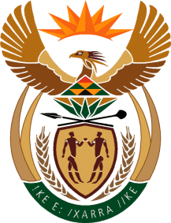

MINISTRY OF TOURISM
REPUBLIC OF SOUTH AFRICA

Private Bag X424, Pretoria, 0001, South Africa. Tel. (+27 12) 444 6780, Fax (+27 12) 444 7027
Private Bag X9154, Cape Town, 8000, South Africa. Tel. (+27 21) 469 5800, Fax: (+27 21) 465 3216

Ref: TM 2/1/1/10

NATIONAL ASSEMBLY:

QUESTION FOR WRITTEN REPLY:
Question Number: 1597
Date of Publication: 26 May 2018
NA IQP Number: 18
Date of reply: 14 June 2018

Mr G R Krumbock (DA) to ask the Minister of Tourism:
(a) What are the reasons for not tabling amendments to the Tourism Act, Act 3 of 2014, which were supposed to be tabled in 2017 and (b) what are the (i) details and (ii) reasons of the proposed amendments? NW1747E
Reply:

- Additional areas were identified for inclusion as amendments of the Tourism Act, 2014. The submission of the Draft Amendment Bill to Cabinet in the Financial Year 2017/18 did not occur in order to accommodate a comprehensive policy review and analysis to inform the drafting of the Bill in the areas indicated below.

- (i) and (ii) The Department seeks to amend the Tourism Act 3, 2014 to provide for:

- Improved governance of SAT
- Implementation of the national grading system
- Professionalisation of the tourist guiding sector
- Regulation of new platforms of tourism services for the sharing economy – eg. Air BnB

