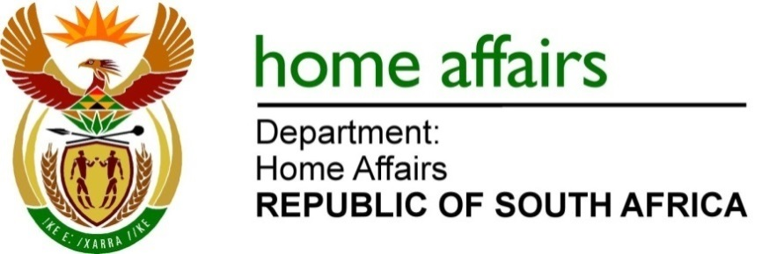

NATIONAL ASSEMBLY

QUESTION FOR WRITTEN REPLY

QUESTION NO.1596

DATE OF PUBLICATION: Friday, 5 May 2023

INTERNAL QUESTION PAPER 15 – 2023
1596. Dr M Q Ndlozi (EFF) to ask the Minister of Home Affairs
Whether the United Arab Emirates president’s family complied with all quarantine and health-related regulations upon arrival at the Bulembu Airport in Qonce, as required by the South African port of entry legislation; if not, why not; if so, what are the relevant details? NW1859E

REPLY:
Yes, the health related issues were complied with by the officials of the Border Management Authority which now comprise officials transferred from the Department of Agriculture.

END

