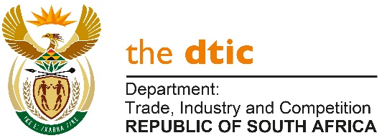

THE NATIONAL ASSEMBLY

QUESTION FOR WRITTEN REPLY

QUESTION NO 1596

DATE PUBLISHED: 29 APRIL 2022

Mrs S P Kopane (DA) to ask the Minister of Trade, Industry and Competition:
Whether (a) his department and/or (b) entities reporting to him concluded any commercial contracts with (i) the government of the Russian Federation and/or (ii) any other entity based in the Russian Federation since 1 April 2017; if not, what is the position in this regard; if so, for each commercial contract, what are the (aa) relevant details, (bb) values, (cc) time frames, (dd) goods contracted and (ee) reasons why these goods could not be contracted in the Republic?NW1921E

Reply
(a) (i) (ii) (aa) (bb) (cc) (dd) (ee)
The department advises that it, through DIRCO concluded a Tenancy Agreement for the dtic’s Foreign Economic Representative’s residential accommodation. The Tenancy Agreement came to an end on the 30th May 2020. The Department advises that the value since 1 April 2017 to 30 May 2020 was R6.2 million.

The department through the Export Marketing and Investment Assistance (EMIA) scheme entered into annual agreements for the rental of space during the annual World Food Moscow exhibition to showcase South African products. The total value for 1 April 2017 to February 2020 was R9.6 million.

(b)(i) (ii) (aa) (bb) (cc) (dd) (ee)
The Department advises that entities reporting to the dtic do not have commercial contracts with the government of the Russian Federation, nor with any entity based in the Russian Federation.

-END-

