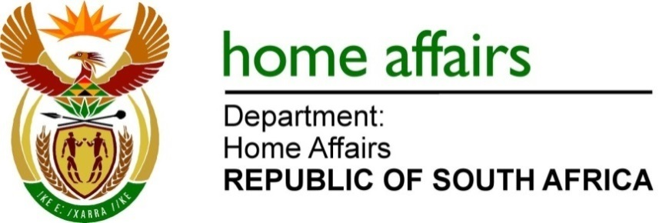

NATIONAL ASSEMBLY

QUESTION FOR WRITTEN REPLY

QUESTION NO.1595

DATE OF PUBLICATION: Friday, 5 May 2023

INTERNAL QUESTION PAPER 15 – 2023

1595. Mrs E N Ntlangwini (EFF) to ask the Minister of Home Affairs

(1) Whether, in light of the visit of Sheikh Mohamed bin Zayed al Nahyan’s family to the Republic, any prohibited and/or restricted items were identified during the customs inspection; if not, what is the position in this regard; if so,

(2) whether appropriate measures were taken in accordance with the customs and excise regulations; if not, why not; if so, what are the relevant details? NW1858E

REPLY:

(1&2) Yes, customs duties were performed in the presence of members of the South African Police Service and officials of the Border Management Authority (BMA).
END

