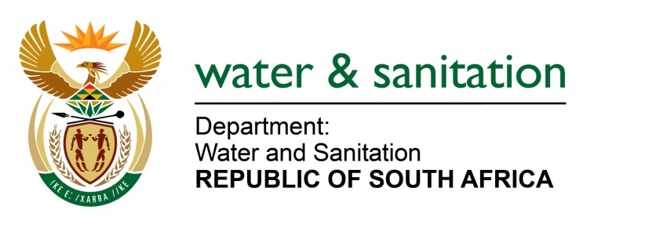

NATIONAL ASSEMBLY

FOR WRITTEN REPLY

QUESTION NO 1595

DATE OF PUBLICATION IN INTERNAL QUESTION PAPER: 27 MAY 2016
(INTERNAL QUESTION PAPER NO. 17)

1595. Mr L J Basson (DA) to ask the Minister of Water and Sanitation:
(1) Whether any South African companies were considered to develop desalination plants along all coastal communities to boost water supply before a partnership was struck around 11 May 2016 with the Islamic Republic of Iran to develop the specified plants; if not, why not; if so,
(2) why did she choose to partner with the Islamic Republic of Iran when many local jobs could have been created if a South African company was to develop the specified plants;
(3) whether any studies were conducted by her department before the specified partnership was struck with Iran; if not, why not; if so, (a) what are the relevant details, (b) what were the outcomes of such studies and (c) who was consulted in this regard? NW1765E
---00O00---
REPLY:

(1) No specific South African or Iranian companies were approached or selected for partnership on desalination. My Department has been working with various active actors nationally and internationally to examine the viability of desalination as an option in South Africa. Refer to Annexure A for the signed agreement.

(2) My Department’s International Engagement with Iran is based on the Bi-National Relations led by the Department of International Relations and Cooperation on issues of national interest for the benefit of the water sector.

(3) Yes, my Department has, through the Water Research Commission (WRC) conducted various studies over time to establish facts on the viability and benefits of desalination in the coastal areas of our country. The relevant details are contained in the study reports or outcomes backed by years of research by the WRC. Different actors and organisations and countries working on desalination were consulted by WRC both locally and internationally. Refer to Annexure B.
---00O00---

