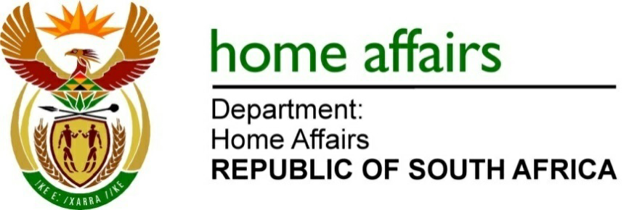
NATIONAL ASSEMBLY

QUESTION FOR WRITTEN REPLY

QUESTION NO.1594

DATE OF PUBLICATION: Friday, 5 May 2023

INTERNAL QUESTION PAPER 15 – 2023

1594. Ms N V Mente (EFF) to ask the Minister of Home Affairs
Whether the United Arab Emirates president’s family did undergo the required customs declarations and inspections for any goods and/or items they brought into the Republic, in accordance with the customs and excise legislation; if not, why not; if so, what are the relevant details? NW1857E

REPLY:
Yes, customs officials performed their duties in the presence of members of the South African Police Service (SAPS) and Border Management Authority officials.

END

