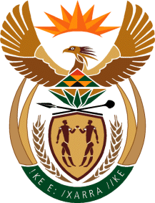

MINISTER IN THE PRESIDENCY: REPUBLIC OF SOUTH AFRICA
Private Bag X1000, Pretoria, 0001, Union Buildings, Government Avenue, PRETORIA
Tel: (012) 300 5200, Website: www.thepresidency.gov.za

NATIONAL ASSEMBLY
WRITTEN QUESTION FOR WRITTEN REPLY
- QUESTION NUMBER: 1594
DATE OF PUBLICATIONS: 29 April 2022

1594. Mr W F Faber (DA) to ask the Minister in The Presidency:
Whether (a) his Office and/or (b) entities reporting to him concluded any commercial contracts with (i) the government of the Russian Federation and/or (ii) any other entity based in the Russian Federation since 1 April 2017; if not, what is the position in this regard; if so, for each commercial contract, what are the (aa) relevant details, (bb) values, (cc) time frames, (dd) goods contracted and (ee) reasons why these goods could not be contracted in the Republic? NW1919E

REPLY:

Given the information at my disposal my Office, Media Development and Diversity Agency and Brand South Africa does not have any commercial contracts with the Government of the Russian Federation and/or any other Entity based in the Russian Federation since 1 April 2017.

Thank you.

