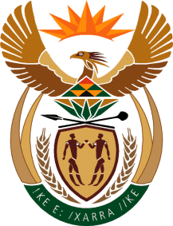

MINISTRY OF TOURISM
REPUBLIC OF SOUTH AFRICA

Private Bag X424, Pretoria, 0001, South Africa. Tel. (+27 12) 444 6780, Fax (+27 12) 444 7027
Private Bag X9154, Cape Town, 8000, South Africa. Tel. (+27 21) 469 5800, Fax: (+27 21) 465 3216

NATIONAL ASSEMBLY:

QUESTION FOR WRITTEN REPLY:
Question Number: 1594
Date of Publication: 28 May 2021
NA IQP Number: 15
Date of reply: 08 June 2021

Mr H S Gumbi (DA) to ask the Minister of Tourism:
(1) What was the purpose of the Ministerial cook off with Mr Somizi Mhlongo on 17 May 2021 ahead of the Budget Vote of her department;
(2) whether any State resources were used to host the event; if not, what is the position in this regard; if so, (a) what amount did the event cost, (b) from what budget were the funds obtained and (c) on what statutory grounds did she rely in this regard? NW1800E
REPLY:

(1) The Ministerial cock-off was part of the pre-Tourism Budget Vote departmental awareness activities, showcasing the work of the department in terms of the participation of graduate Chefs from its training programmes as well as promoting a culture of eating out particularly at township establishments.

(2) (a) The event cost was R150 000,00 (One hundred and fifty thousand rand) covering the venue and mobile kitchen hire, event staffing, safety and event compliance requirements, the stage, sound system, food supplies, exhibition setup, publicity including live-streaming of activities and sound system.
It is also important to state that there was no payment made to Mr Somizi Mhlongo and the department notes with concern the general public perception that he benefited from the event, which is not the case.

(b) The funds were obtained from the Chief Directorate: Communications from its 2021/22 MTEF allocation.

(c) The Tourism Act, No 3 of 2014 provides for development and promotion of tourism in South Africa.

