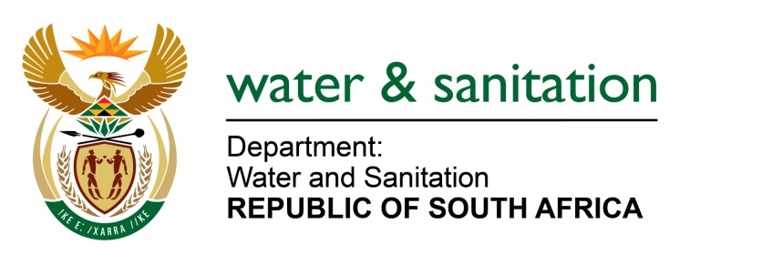

NATIONAL ASSEMBLY
FOR WRITTEN REPLY

QUESTION NO 1594

DATE OF PUBLICATION IN INTERNAL QUESTION PAPER: 30 APRIL 2015
(INTERNAL QUESTION PAPER NO. 12)
1594. Mr A M Mpontshane (IFP) to ask the Minister of Water and Sanitation:
(1) (a) How many criminal dockets were opened with the SA Police Service for (i) failing to comply with water use authorizations or (ii) using water without authorization as required by the National Water Act, Act 36 of 1998, and (b) what is the breakdown of the figures for each (i) region and (ii) sector;
(2) (a) how many criminal dockets were handed over to the National Prosecuting Authority (NPA) in the (i) 2013-14 and (ii) 2014-15 financial years for offences in terms of the National Water Act, Act 36 of 1998, and (b) what is the breakdown of the figures for each (i) region and (ii) sector;
(3) (a) how many criminal dockets for transgressions of the National Water Act, Act 36 of 1998, did the NPA decline to prosecute in the specified periods and (b) what is the breakdown of the figures for each (i) region and (ii) sector;
(4) how many convictions were secured in each of the specified periods for transgressions of the National Water Act, Act 36 of 1998, and (b) what is the breakdown of the figures for each (i) region and (ii) sector;
(5) What was the (a) highest monetary fine and (b) longest sentence of direct imprisonment obtained for convictions for offences of transgressions of the National Water Act, Act 36 of 1998, in each specified period? NW1807E

---00O00---

REPLY:

(1)(a) My Department has opened a total of Sixty Seven (67) cases with the South African Police Service (SAPS) for contravening the National Water Act (Act no 36 of 1998) (NWA). (i), one (1) case was opened for not complying with water use authorizations and (ii) Fifty Eight (58) were cases opened for engaging in water uses without authorisation.

(1)(b) Below is the region and sector breakdown of criminal cases opened:
Criminal Cases Opened with SAPS
- Region | - Sectors
 | Mining | Agriculture | Industries | Water Services Authorities | Tourism | Total
Eastern Cape | - | - | - | - | - | -
Free State | - | 1 | - | 7 | - | 8
Gauteng | 2 | 6 | - | - | - | 8
KwaZulu-Natal | 10 | - | 1 | - | - | 11
Limpopo | - | 1 | - | - | - | 1
Mpumalanga | 9 | 14 | 3 | 1 | 1 | 28
North West | 1 | 2 | - | 1 | - | 4
Northern Cape | 4 | - | - | - | - | 4
Western Cape | - | - | 2 | 1 | - | 3
Total | 26 | 24 | 6 | 10 | 1 | 67

(2) The relevant Department to answer the question is the South African Police Service (SAPS).

(3) The relevant Department to answer the question is the National Prosecuting Authority (NPA).

(4) The relevant Department to answer the question is the National Prosecuting Authority (NPA).
(5)(a) The highest monetary fine was One Million Rand (R1 000 000.00) in 2013/2014.
(5)(b) No imprisonment was obtained for convictions for the offences of transgressions of the NWA.
---00O00---

