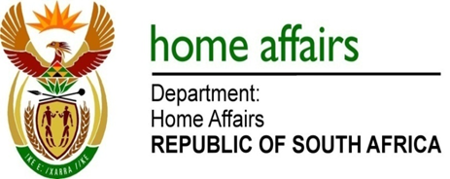

NATIONAL ASSEMBLY

QUESTION FOR WRITTEN REPLY

QUESTION NO. 1593

DATE OF PUBLICATION: FRIDAY, 25 MAY 2018

INTERNAL QUESTION PAPER 18 OF 2018

1593. Mr M H H Hoosen (DA) to ask the Minister of Home Affairs:

What (a) number of applications for refugee status from Somali nationals have been (i) received, (ii) approved and (iii) rejected (aa) in each of the past three financial years and (bb) since 1 April 2018 and (b) are the main reasons for rejecting the specified applications? NW1743E

REPLY:

- Reporting of asylum statistics is in line with calendar years (January to December):

Year | - Received | - Approved | - Rejected
(aa) 2015 | *2079 | 618 | 1112
(aa) 2016 | 1643 | 1169 | 904
(aa) 2017 | 1932 | 732 | 1500
(bb) 2018 | 208 | 93 | 137

* The number of applications approved and rejected may differ with the total received in the specific year as not all applications received are finalised within the same year and there also applications that are finalised from a carryover from previous years.

- Main reasons for the rejections are :

- Applicants with claims that come from the peaceful parts of Somalia like Somaliland and Puntland.
- Applicants that are in RSA for other reasons than those stipulated in Section 3 of the Refugees Act 130 of 1998.
- Applicants who were granted refugee status before and withdrew their refugee status because they wanted to return to their country of origin and who failed to demonstrate changed circumstances that forced them to return to South Africa to re-apply for asylum.

- Applicants who already enjoy protection in other countries that are signatory to the UN Convention and who failed to give compelling reasons as to why they left such protection.
- Applicants who fall under the exclusion clause.
- Applicants who re-availed themselves to their country of origin whilst applying for asylum in South Africa.

