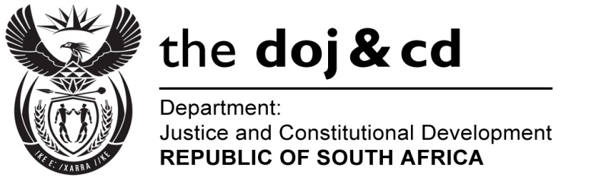

NATIONAL ASSEMBLY
QUESTION FOR WRITTEN REPLY
PARLIAMENTARY QUESTION NO: 1593
DATE OF QUESTION: 27 MAY /2016

DATE OF SUBMISSION: 07 JUNE 2016

Mr K P Robertson (DA) to ask the Minister of Justice and Correctional Services:
- Whether, with reference to (a) the Minister of Police’s reply to question 671 on 1 April 2016 and (b) his reply to question 1275 on 20 May 2016, a certain docket (details furnished) has been submitted for prosecution yet; if not,
- (a) is the specified case still being discussed at the National Prosecuting Authority and (b) what progress has been made with regard to establishing the course of action for the specified case; if so, what (i) is the charge against the accused and (ii) progress has been made with the specified prosecution to date?
NW1763E
REPLY:
I wish to inform the Honourable Member that the National Prosecuting Authority has informed me that:
- The said docket was indeed forwarded to the Deputy Director Public Prosecutions: Nelspruit for a decision on 31 March 2016.
- The docket was returned to the Senior Public Prosecutor on 10 May 2016 with a request for further investigation, who in turn sent an instruction to the South African Police Services to conduct further investigation as directed.

