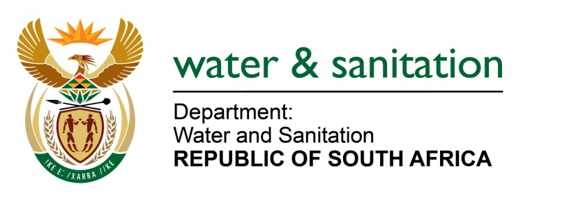

NATIONAL ASSEMBLY

FOR WRITTEN REPLY

QUESTION NO 1586

DATE OF PUBLICATION IN INTERNAL QUESTION PAPER: 27 MAY 2016
(INTERNAL QUESTION PAPER NO. 17)

1586. Mr C D Matsepe (DA) to ask the Minister of Water and Sanitation:

(a) What amount is owed to (i) the Magalies and (ii) Lepelle Northern water boards by each local municipality in Limpopo, (b) what amount is owed in each specified case, (c) for how many days have the debts been outstanding, (d) why has it taken so long to settle the debts, (e) when will the debts be paid in full and (f) what arrangements, if any, have been made to settle the outstanding debt? NW1756E
---00O00---
REPLY:

Refer to the table below for amount owed to Magalies Water Board:
(a)(i) | (b) | (c) | (d) | (e) | (f)
Thabazimbi Local Municipality | R28 912237 | More than 3 years | The municipality is experiencing cash flow challenges. | Unknown at this stage as the municipality is under administration. | The municipality has made a commitment to make a payment of R1 million per month until National Treasury has approved the finance recovery plan.
Modimolle Local Municipality | R2 390962 | 0 | The account is on current | 31 May 2016 | N/A
BelaBela Municipality | R1 620436 | 0 | The account is on current | 31 May 2016 | N/A

Refer to the table below for amount owed to Lepelle Northern Water Board:
(a)(ii) | (b) | (c) | (d) | (e) | (f)
Ba-Phalaborwa Municipality | R69,6m | 120 days+ | Availability of funds | By 2019 | The settlement agreement is in place and adhered to by the Water Services Authority (WSA)
Capricorn District Municipality (CDM Urban) | R3m | Current | N/A | N/A
Greater Letaba Municipality | R1m | Current | N/A | N/A
Greater Tzaneen Municipality | R0.78m | Current | N/A | N/A
GSDM (Fetakgomo Local Municipality) | R6,4m | 120 days+ | Availability of funds |  | Negotiations with the WSA are taking place
GSDM (Makhuduthamaga Local Municipality) | R16,1m | 120 days+ | Availability of funds |  | Negotiations with the WSA are taking place
Marble Hall Municipality | R1,m | 120 days+ | Availability of funds |  | Negotiations with the WSA are taking place
Mogalakwena Local Municipality | R5,6m | Current | N/A | N/A
Mopani District Municipality | R249,6m | 120 days+ | Availability of funds | By 2019 | The settlement agreement is in place and adhered to by the WSA
Polokwane Municipality | R13,4m | Current | N/A | N/A | N/A
Lepelle Nkumpi Municipality (CDM Rural) | R2M | Current | N/A | N/A
Greater Tubatse Local Municipality | R20,7m | 120 days+ | Availability of funds |  | Negotiations with the WSA are taking place

---00O00---

