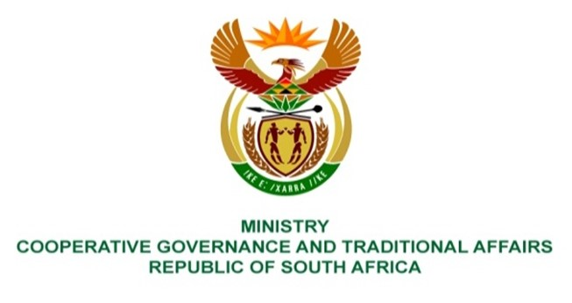

NATIONAL ASSEMBLY
QUESTIONS FOR WRITTEN REPLY

QUESTION NUMBER 1284
DATE OF PUBLICATION: 14 MAY 2021

QUESTION:

1584. Mrs A Steyn (DA) to ask the Minister of Cooperative Governance and Traditional Affairs:

QUESTION:
Whether her department has any agricultural land registered in the name of the State in the OR Tambo District Municipality in the Eastern Cape; if not, what is the position in this regard; if so, (a) what number of hectares, (b) who is currently occupying the land and (c) what is it being used for?
NW1790E

REPLY:
No COGTA does not have any agricultural land. Issues relating to agricultural land registered in the name of the state are administered by the Department of Rural Development and Land Reform. The Honourable member is advised to direct this question to the relevant department.

