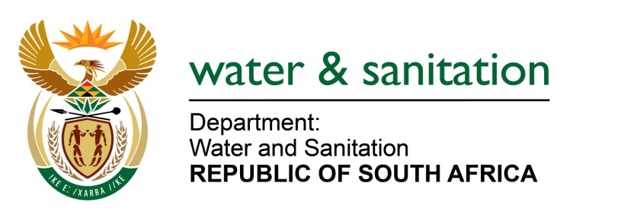

**NATIONAL ASSEMBLY**

**FOR WRITTEN REPLY**

**QUESTION NO 1583**

**DATE OF PUBLICATION IN INTERNAL QUESTION PAPER: 29 APRIL 2022**

**(INTERNAL QUESTION PAPER NO. 15)**

**1583. Mr N E Hinana (DA) to ask the Minister of Water and Sanitation:**

Whether (a) his department and/or (b) entities reporting to him concluded any commercial contracts with (i) the government of the Russian Federation and/or (ii) any other entity based in the Russian Federation since 1 April 2017; if not, what is the position in this regard; if so, for each commercial contract, what are the (aa) relevant details, (bb) values, (cc) time frames, (dd) goods contracted and (ee) reasons that the goods could not be contracted in the Republic?

NW1908E

---00O00---

**MINISTER OF WATER AND SANITATION**

There are no commercial contracts entered into by my Department or any of the Entities reporting to me with the govenment of the Russian Federation.

---00O00---