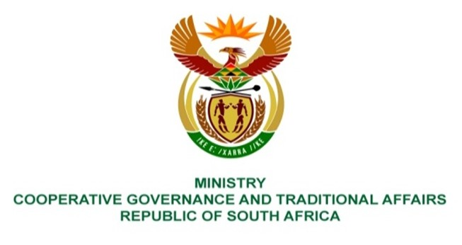

NATIONAL ASSEMBLY
QUESTIONS FOR WRITTEN REPLY
QUESTION NUMBER 158

158. Mrs S M Mokgotho (EFF) to ask the Minister of Cooperative Governance and Traditional Affairs:
What (a) intervention measures has her department put in place to assist the Bojanala Platinum District Municipality in fixing the road infrastructure of Ward 27 in Lethabong Township, which is in a shocking state, and (b) is the timeline and/or exact dates of the intervention? NW163
REPLY:
- Section 154 of the Constitution provides that the national government and provincial governments must support and strengthen the capacity of municipalities to perform their functions. The Department of Cooperative Governance (DCOG), through the Municipal Infrastructure Support Agent (MISA), provides technical support and builds the capacity of municipalities to effectively plan, deliver, operate, and maintain their service delivery infrastructure. MISA has to-date deployed 5 technical professionals, that includes 4 professionally registered built environment professionals, to support Bojanala Platinum District Municipality (BPDM) together with the local municipalities under its jurisdiction, in accordance with the District Development Model (DDM).

The Lethabong Township road in question is a district road that falls under the responsibility of the North West Department of Public Works and Roads Department (hereinafter known as the Department). The North West Provincial Route Number for Lethabong Road is D1344. MISA’s technical support to BPDM includes coordinating and monitoring the Department and all other implementing agents of infrastructure in the district to ensure successful completion.

- It is a provincial road and the province appoint contractors. The project duration is estimated to be four (4) months.
End.

