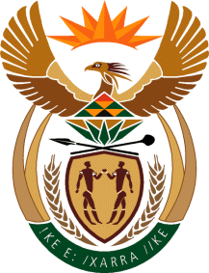

MINISTRY OF TOURISM
REPUBLIC OF SOUTH AFRICA

Private Bag X424, Pretoria, 0001, South Africa. Tel. (+27 12) 444 6780, Fax (+27 12) 444 7027
Private Bag X9154, Cape Town, 8000, South Africa. Tel. (+27 21) 469 5800, Fax: (+27 21) 465 3216

NATIONAL ASSEMBLY:

QUESTION FOR WRITTEN REPLY:
Question Number: 1579
Date of Publication: 28 May 2021
NA IQP Number: 15
Date of reply: 08 June 2021

Ms H S Winkler (DA) to ask the Minister of Tourism:
Whether her department has engaged with the Department of Cooperative Governance and Traditional Affairs to address the issue of (a) sewage spills and water course pollution that is severely impacting tourism, for example the status of blue flag beaches, and (b) dam and river pollution that has an impact on sporting events such as the Duzi Canoe Marathon; if not, (i) why not and (ii) how does her department intend to address the specified problem; if so, what are the details of the plan to address the impact of water pollution on tourism? NW1785E
REPLY:
The management of water resources and water infrastructure is the competency of the relevant Local Authority and the Department of Water Affairs and Sanitation as well as the relevant Water Board. The matter of sewerage spills and water pollution are usually addressed by these competent authorities. Where these matters are raised directly with the Department of Tourism, they are then brought to the attention of the competent authorities for resolution. It is suggested that the Honourable member refers her question to the Minister of Water Affairs and Sanitation as well as the relevant Provincial and Local Authority.

