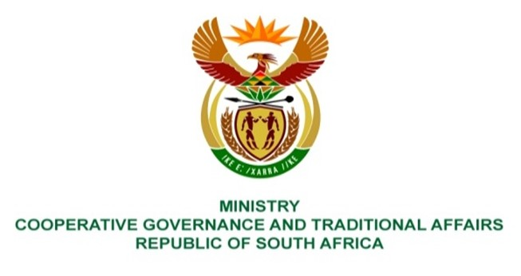

NATIONAL ASSEMBLY
QUESTION FOR WRITTEN REPLY

QUESTION NUMBER 1574
DATE OF PUBLICATION: 29 APRIL 2022

QUESTION:

1574. Mr E J Marais (DA) to ask the Minister of Cooperative Governance and Traditional Affairs:
Whether (a) her department and/or (b) entities reporting to her concluded any commercial contracts with (i) the government of the Russian Federation and/or (ii) any other entity based in the Russian Federation since 1 April 2017; if not, what is the position in this regard; if so, for each commercial contract, what are the (aa) relevant details, (bb) values, (cc) time frames, (dd) goods contracted and (ee) reasons that the goods could not be contracted in the Republic? NW1899E

REPLY:

The Department has no commercial contracts with the government of the Russian Federation

