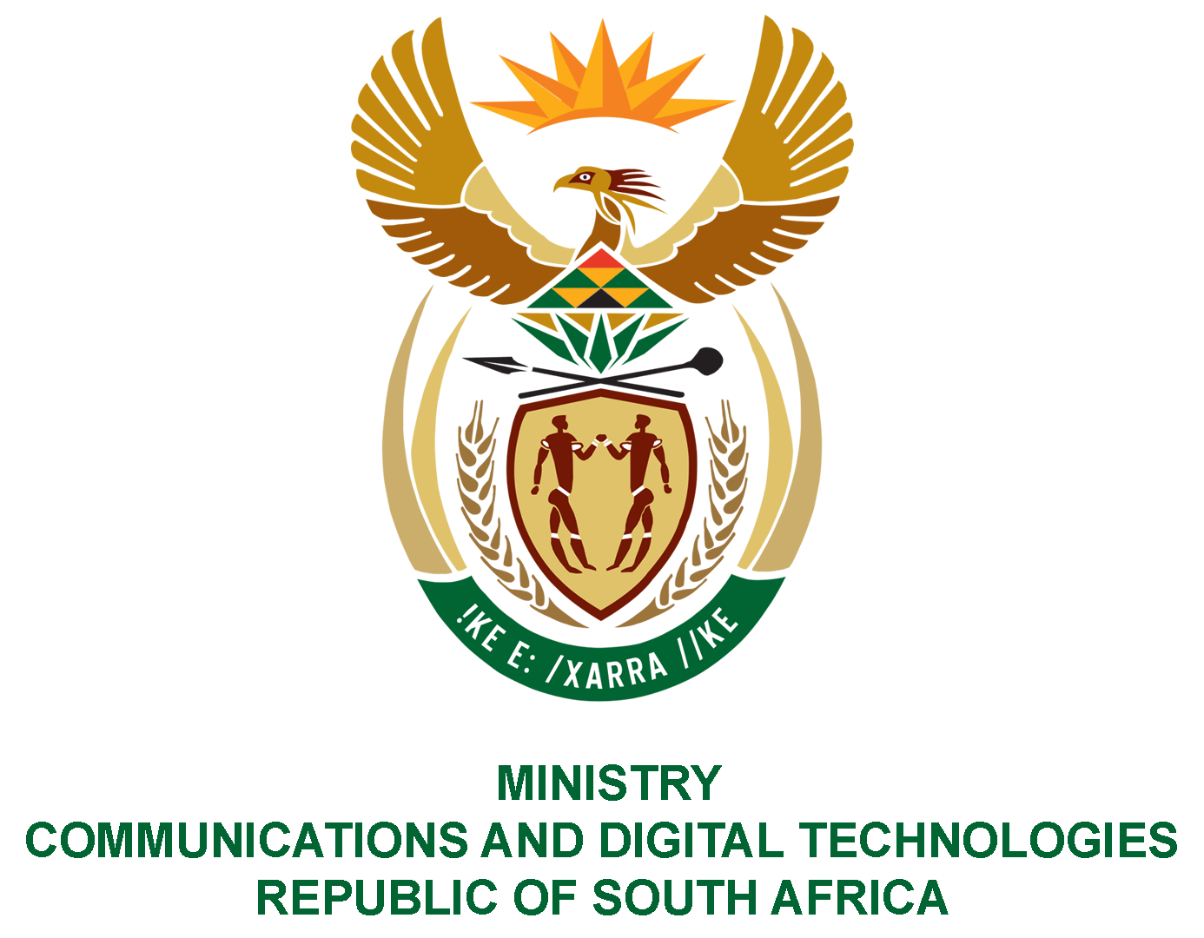

PARLIAMENT OF THE REPUBLIC OF SOUTH AFRICA

NATIONAL ASSEMBLY

WRITTEN REPLY

QUESTION: 1573

DATE OF PUBLICATION: 29 APRIL 2022
QUESTION PAPER NO: 15

Ms T. M Mbabama (DA) to ask the Minister of Communications and Digital Technologies:
Whether (a) her department and/or (b) entities reporting to her concluded any commercial contracts with (i) the governmemt of the Russian Federation and/or (ii) any other entity based in the Russian Federation since 1 April 2017; if not, what is the position in this regard; if so, for each commercial contract, what are the (aa) relevant details, (bb) values, (cc) time frames, (dd) goods contracted and (ee) reasons that the goods could not be contracted in the Republic?
NW1898E
REPLY:

I was advised by the Department and Entities as follows:

(a)(i) No
(b)(ii) No

(aa-ee) Not applicable

