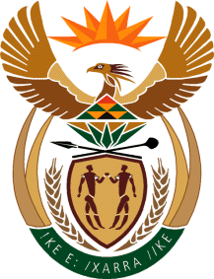

MINISTRY OF TOURISM
REPUBLIC OF SOUTH AFRICA

Private Bag X424, Pretoria, 0001, South Africa. Tel. (+27 12) 444 6780, Fax (+27 12) 444 7027
Private Bag X9154, Cape Town, 8000, South Africa. Tel. (+27 21) 469 5800, Fax: (+27 21) 465 3216

Ref: TM 2/1/1/10

QUESTION FOR WRITTEN REPLY:
Question Number: 1565
Date of Publication: 20 May 2016
NA IQP Number: 16
Date of reply: 1 June 2016

Mr D W Macpherson (DA) to ask the Minister of Tourism:
(a) What amount did (i) his department and (ii) each entity reporting to him spend on advertising in the 2015-16 financial year and (b) how much has (i) his department and (ii) each entity reporting to him budgeted for advertising in the 2016-17 financial year? NW1736E

Reply

(a) (i) R 2 673 358.61 (Department of Tourism)
(ii) R 417 031 499.00 (SA Tourism)

(b) (i) R 6 500 000.00 (Department of Tourism)
(ii) R 313 124 285.00 (SA Tourism)

