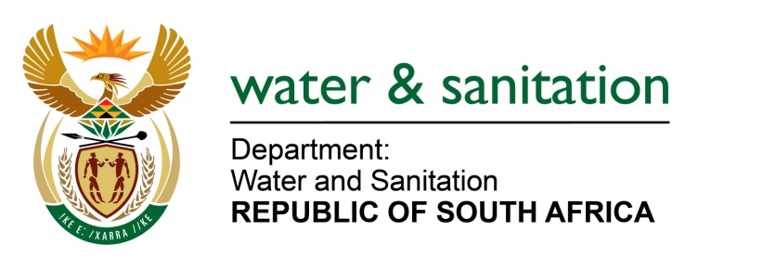

FOR WRITTEN REPLY

QUESTION NO 1563

DATE OF PUBLICATION IN INTERNAL QUESTION PAPER: 2 JUNE 2017
(INTERNAL QUESTION PAPER NO. 20)
1563. Mr L J Basson (DA) to ask the Minister of Water and Sanitation:
(1) What are the full details of each contract awarded by the Trans Caledon Tunnel Authority (a) in each of the past three financial years and (b) since 1 April 2017, in each case specifying (i) the name and (ii) cost,
(2) (a) did each contract go out on tender, (b) who was awarded each tender, (c) how is each project funded and (d) what is the current status of each project;
(3) whether each project complies with the regulations of the Public Finance Management Act, Act 1 of 1999, as amended; if not, in each case, why not? NW1764E
---00O00---

Reply:

Refer to the table below for the breakdown responses.

---00O00--
ONTRACTS AWARDED BY TCTA FROM 2014/15, 2015/16 AND 2016/17 FINANCIAL YEARS
- (i)  Contract Description | - (b)  Date Awarded | 2(b)  Contractor/ Supplier | (ii)  Contract Amount | 2(a)  Open Tender or Close Tender or Exception | 2(c)  Where applicable, How is each project Funded | 2 (d)  Status of the project | (3)  Compliance with regulations of the Public Finance Management Act (Yes or No)
Maintenance of UPS System, Generator, Access control and CCTV | Apr-14 | M Projects | R 1 044 0000 | Single Source recommended for maintenance of the equipment which were installed by the same service provider who was appointed through an open tender process. | Commercial funding which is repaid via water tariffs from the Vaal River System | Current | Yes
Construction of AMD facilities at Eastern Basin | May-14 | CMC-PG JV | R 1 122 241 835.91 | Open Tender | Commercial funding which is repaid via water tariffs from the Vaal River System and 67% refundable from the fiscus | Complete | Yes
Audio Visual Equipment | May-14 | Sumsung Business Solutions | R 1 620 0000.00 | Single Source for maintenance of the equipment which were installed by the same service provider who was appointed through an open tender process. | Commercial funding which is repaid via water tariffs from the Vaal River System | Current | Yes
Land Valuation Services for Sludge Disposal for the Central Basin, Eastern and Western Basin | Jun-14 | Griffiths Valuations | R 185 811.25 | Single Source from the database which was set up after an open tender process. | Commercial funding which is repaid via water tariffs from the Vaal River System | Complete | Yes
Independent Environmental Auditor for AMD Eastern basin | Sep-14 | EP3 | R 179 013.33 | Quotation Process | Commercial funding which is repaid via water tariffs from the Vaal River System and 67% refundable from the fiscus | Complete | Yes
Disaster Recovery Services | Sep-14 | Continuity South Africa | R 2 870 008.34 | Single Sourcing | Commercial funding which is repaid via water tariffs from the Vaal River System | Expired | Yes
Health and Safety Consultant at AMD Eastern basin | Oct-14 | Nemai Consulting | R 417 764.40 | Open Tender | Commercial funding which is repaid via water tariffs from the Vaal River System and 67% refundable from the fiscus | Complete | Yes
Mobile Phone Services | Dec-14 | Vodacom | R 3 320 955.40 | Single Source-negotiated route after failure of a close tender process. | Commercial funding which is repaid via water tariffs from the Vaal River System | Current | Yes
Operation and Maintenance for AMD facilities at Central Basin | Jan-15 | Group Five | R 215 863 561.66 | Contract extension. | Commercial funding which is repaid via water tariffs from the Vaal River System and 67% refundable from the fiscus | Complete | Yes
Construction of AMD facilities at Western Basin | Jan-15 | Group Five | R 92 000 000.00 | Single Source, followed after the open tender process failed. | Commercial funding which is repaid via water tariffs from the Vaal River System and 67% refundable from the fiscus | Current | Yes
Appointment of Corporate Insurance Service provider | Feb-15 | GIB Insurance Brokers | R 102 444.00 | Open Tender | Commercial funding which is repaid via water tariffs from the Vaal River System | Current | Yes
Treasury Management System | Jun-15 | Fikon | R 6 131 034,00 | Open Tender | Commercial funding which is repaid via water tariffs from the Vaal River System | Current-implementation | Yes
Rental of Multi-Function Printing Devices for 36 Months | Dec-15 | Konica Minolta | R 3 848 349.70 | Open Tender | Commercial funding which is repaid via water tariffs from the Vaal River System | Current | Yes
SCM, Financial Accounting System | Jan-16 | ICT Works | R 15 170 305.98 | Open Tender | Commercial funding which is repaid via water tariffs from the Vaal River System | Current | Yes
HRM System | Jan-16 | ICT Works | R 6 270 000.00 | Single sourcing followed after the open tender process failed. | Commercial funding which is repaid via water tariffs from the Vaal River System | Current | Yes
Short term operation and maintenance of AMD Central basin | Apr-16 | Intelligent Water Solutions (IWS) | R 55 146 662,91 | Single Source | Commercial funding which is repaid via water tariffs from the Vaal River System and 67% refundable from the fiscus | Current- open tender process underway. | Yes
Operation and maintenance of AMD facilities at Eastern Basin | Aug-16 | CMC-PG JV | R 80 000 000.00 | Contract extension to provide operations and maintenance services to allow conclusion of an open tender process. | Commercial funding which is repaid via water tariffs from the Vaal River System and 67% refundable from the fiscus | Current | Yes
Procurement of pool vehicles | Jan-17 | Nissan | R 498 914.03 | National Treasury Transversal Contract | Commercial funding which is repaid via water tariffs from the Vaal River System | Once-off. | Yes
Psychometric Assessments | Feb-17 | Work Dynamics | R 982 708.76 | Open Tender | Commercial funding which is repaid via water tariffs from the Vaal River System | Current | Yes
Travel Management Service | Mar-17 | Travel With Flair | Management fee (R 7 000 000.00) | Open Tender | Commercial funding which is repaid via water tariffs from the Vaal River System | Extended by six months until September 2017 | Yes
Travel Management Services | Mar-17 | Gemini | Management fee (R 4 400 000.00) | Open Tender | Commercial funding which is repaid via water tariffs from the Vaal River System | Extended by six months until September 2017 | Yes
Total Soft Services Contract for facilities Management | Mar-17 | Afri Services | R 7 395 031.02 | Open Tender | Commercial funding which is repaid via water tariffs from the Vaal River System | On going | Yes
VAT Consulting Services | Mar-17 | PWC | R 160 000.00 | Single Source | Commercial funding which is repaid via water tariffs from the Vaal River System | On-going. | Yes

