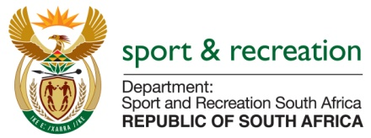

PARLIMENTARY QUESTION FOR THE MINISTER

QUESTION NUMBER 1562

1562. Dr A Lotriet (DA) to ask the Minister of Sport and Recreation:
(a) What amount did (i) his department and (ii) each entity reporting to him spend on advertising in the 2015-16 financial year and (b) how much has (i) his department and (ii) each entity reporting to him budgeted for advertising in the 2016-17 financial year? NW1733E

REPLY
We are still gathering data from entities and information is not readily available

