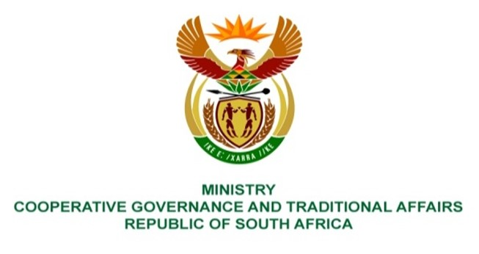

NATIONAL ASSEMBLY
QUESTIONS FOR WRITTEN REPLY

QUESTION NUMBER
DATE OF PUBLICATION: 29 APRIL 2022

QUESTION:

1560. Mrs S M Mokgotho (EFF) to ask the Minister of Cooperative Governance and Traditional Affairs:
By what date will mass lights be installed in Ward 6 in the Moses Kotane Local Municipality? NW1885E

REPLY:

Moses Kotane Local Municipality (MKLM) provided for installation of high mast lights in Ward 6 in its current 3-year capital budget plan and 2021/22 Integrated Development Plan. According to MMKLM, MKLM installed high mast lights in Motlhabe village in Ward 6 this financial year and has planned to install high mast lights in Mapaputle and Molorwe villages in Ward 6 in the 2022/23 financial year by the 30th of June 2023.

