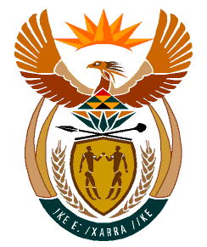

MINISTRY
HUMAN SETTLEMENTS
REPUBLIC OF SOUTH AFRICA

Private Bag X645, Pretoria, 0001. Tel: (012) 421 1309, Fax: (012) 341 8513

Private Bag X9029, Cape Town, 8000. Tel (021) 466 7603, Fax: (021) 466 3610

NATIONAL COUNCIL OF PROVINCES
QUESTION FOR WRITTEN REPLY
QUESTION NO.:1559
DATE OF PUBLICATION: 2022/04/29

Ms N P Sonti (EFF) to ask the Minister of Human Settlements:
What intervention measures have been put in place to provide housing to the community of Ward 6 in the Moses Kotane Local Municipality that has been waiting to be allocated housing since the contractor left without completing building their houses in 2018?

REPLY

The North West Provincial Department of Human Settlements technical team has completed the quantification of all the houses so that it can extend the scope of the developer to complete all the incomplete houses before the end of of the current financial year.

