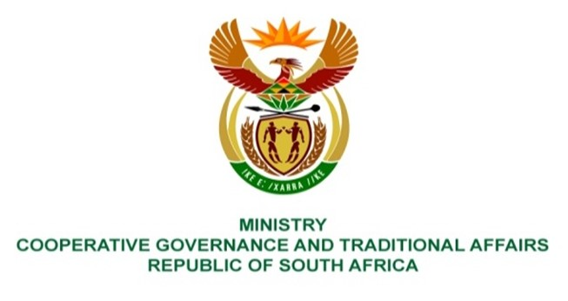

NATIONAL ASSEMBLY
QUESTIONS FOR WRITTEN REPLY

QUESTION NUMBER 1553
DATE OF PUBLICATION: 29 APRIL 2022

QUESTION:

1553. Mr A Matumba (EFF) to ask the Minister of Cooperative Governance and Traditional Affairs:
By what date will a bridge be built in Valdezia, Makhado, Limpopo, where the community is left stranded when it rains, as the bridge is the only entrance to Mphombo Block in Valdezia? NW1877E

REPLY:

Makhado Local Municipality (MLM) is currently constructing the culvert bridge and the progress on the 3rd of May 2022 is as per pictures below. According to MLM, the completion date is the 31st of May 2022.

