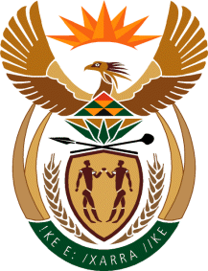

MINISTER IN THE PRESIDENCY: REPUBLIC OF SOUTH AFRICA
Private Bag X1000, Pretoria, 0001, Union Buildings, Government Avenue, PRETORIA
Tel: (012) 300 5200, Website: www.thepresidency.gov.za

NATIONAL ASSEMBLY – INTERNAL QUESTION PAPER

QUESTION FOR ORAL REPLY

QUESTION NUMBER: 1553

Ms S P Kopane (DA) to ask the Minister in The Presidency:

(a) What amount did (i) the Office of The Presidency and (ii) each entity reporting to him spend on advertising in the 2015-16 financial year and (b) how much has (i) the Office of The Presidency and (ii) each entity reporting to him budgeted for advertising in the 2016-17 financial year? [NW1724E]

REPLY:

The Department of Planning, Monitoring and Evaluation (DPME) spent R1 598 million from a budget of R3 670 million. Statistics South Africa spent 6. 870 million from a budget of 5. 281 million.

