National Assembly

Question No: 1552

1552. Mrs N J Nolutshungu (EFF) to ask the Minister of Transport:
What steps has been taken by his department to ensure that Metrorail is able to (a) guarantee commuter safety, (b) protect against cable theft and vandalism of the infrastructure, (c) arrest and subsequently prosecute those responsible for vandalism of infrastructure and (d) get the service up and running to its full capacity within set time frames? NW1928E
Reply:

- PRASA resumed its Metrorail Operation on 01 July 2020, in all Regions (Western Cape, Eastern Cape, KwaZulu Natal and Gauteng) in line with the level 3 lockdown regulations, governed by the risk adjustment strategy implemented by the Government in an attempt to limit the spread of Corona virus pandemic. The Metrorail services resumed in the following corridors at 30% capacity in line with the regulations:
Western Cape | KwaZulu-Natal | Gauteng | Eastern Cape
- Cape Town - Retreat (Wynberg) | - Durban - Umlazi  - Durban - Kwamashu | - Pienaarspoort - Pretoria | - Port Elizabeth -Uitenhage  - East London - Berlin

Following the Minister of Transport’s announcement on 16 July 2020 allowing commuter rail operations to increase the loading capacity to 70%, Metrorail has accordingly increase its loading capacity in the currently operating corridors to 52% from Monday, 03 August 2020, informed by the following risk-based scenarios:

52% Capacity | 70% Capacity
Social distancing for standing is 0.5m apart and all seats occupied with commuters wearing masks. Total in each train set is 1161 commuters | Social distancing for standing is 0.2 to 0.3m apart and all seats occupied with commuters wearing masks. Total in each train set is 1540 commuters
Risk Mitigations
The following measures were implemented to mitigate the risk of spreading the virus:
- All Commuters are sanitised when they enter the station precinct
- No socialising in the train.
- No eating in the train.
- Maintain appropriate ventilation inside the train - Windows to be opened by at least 5cm.
- No handshaking greetings.
- Commuters and staff strictly wear face mask on board the train.
- Protection Officials and Marshalls are deployed on board to enforce compliance.
- Train surfaces are disinfected before the train trip and at turnaround stations.

In addition, commuters are encouraged not to touch surfaces where possible in order to reduce the spread of the virus.The current security arrangements remain in place and supported by platform marshals to enforce compliance with the regulations.
Metrorail will continue to monitor the associated risk and based on the lessons learned and the attendant risk assessment, increase the loading capacity to 70%, in line with the current regulations.

- Metrorail Security continuously identify crime hot spot areas and focus actions to ensure asset protection. Teams are deployed in corridors to ensure fast and effective response. Metrorail has advertised 3000 additional security posts nationally with closing date 22 July 2020. In the interim, until 15 August 2020, available security resources will be utilised to mitigate security risks / threats.

PRASA is also involved with Joint Operations with the Rapid Rail Police to create additional capacity to address the prevailing security threats. PRASA is currently engaged in various projects to address permanent and sustainable solutions for mitigation of the security risks associated with cables and infrastructure i.e.:
- Corridor walling;
- Recruitment Process;
- Monitoring Control Rooms;
- Physical Security;
- Armed Response;
- E-Security solution that will deliver protective measures for mission critical assets (substations, relay rooms and high sites)
- Intelligence Driven Security Operations with investigations and criminal forensic support; and
- Drone operations that will focus of infrastructure and cable protection.

- Over 140 suspects have been arrested for various acts of theft of vandalism of PRASA’s infrastructure nationally with Gauteng contributing over 90% of those arrests. Prasa is pursuing various options with specialised units of the SAPS and the NPA to ensure that perpetrators are effectively prosecuted and receive stiffer sentences are effected, these efforts have been necessitated by the ease in which bail is being granted to suspects even in instances where it is established that they are foreign citizens who might not easily be confined to the borders of RSA.

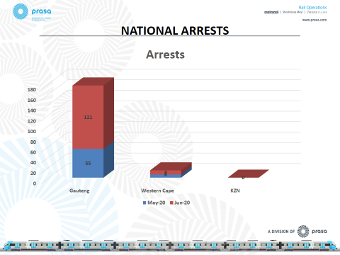

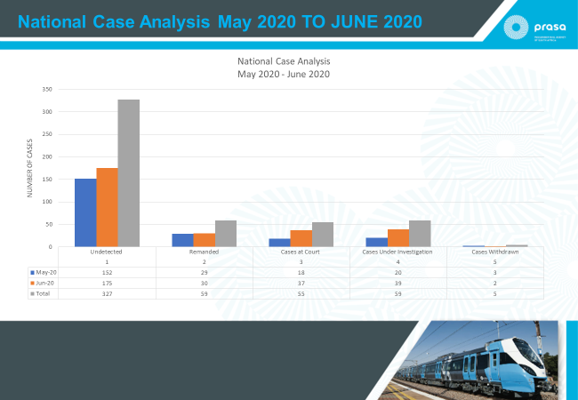

- Services will gradually resume in line with the adopted infrastructure and security plan and in compliance with COVID-19 Directions. The focus will be on corridors with high passenger demand and with less repair work required on vandalised infrastructure and station facilities. In Gauteng, due to damage and vandalism to Overhead Traction Equipment (OHTE), services will initially be rendered using diesel traction whiles OHTE are being repaired and security services are rolled out.

The table below gives an indication of the planned resumption of services:

