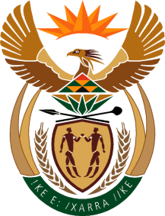

MINISTRY OF TOURISM
REPUBLIC OF SOUTH AFRICA

Private Bag X424, Pretoria, 0001, South Africa. Tel. (+27 12) 444 6780, Fax (+27 12) 444 7027
Private Bag X9154, Cape Town, 8000, South Africa. Tel. (+27 21) 469 5800, Fax: (+27 21) 465 3216

Ref: TM 2/1/1/10

NATIONAL ASSEMBLY:

QUESTION FOR WRITTEN REPLY:
Question Number: 1550
Date of Publication: 2 June 2017
NA IQP Number: 20
Date of reply: 22 June 2017

Ms J F Terblanche (DA) to ask the Minister of Tourism

Whether the 9% increase in tourist arrivals from the United States of America between 2015 and 2016 can be attributed to SA Tourism’s advertising spend in that country; if not, what are the reasons for the 9% increase in arrivals; if so, to what extent can the 9% increase in arrivals be attributed to SA Tourism’s advertising spend? NW1751E

Reply:
- Whether the 9% increase in tourist arrivals from the United States of America between 2015 and 2016 can be attributed to SA Tourism’s advertising spend in that country.

The 9% increase in tourist arrivals from the United States of America was due to collaborative efforts between SA Tourism, Trade and other SA Inc partners such as Brand SA and SAA.

- What are the reasons for the 9% increase in arrivals?

The improved perceptions of safety vis-à-vis the world competitive environment and the favourable Dollar/Rand exchange rate in 2015-16 encouraged many American travellers to consider South Africa as a value for money travel destination.

- To what extent can the 9% increase in arrivals be attributed to SA Tourism’s advertising spend.

SA Tourism partnered with trade in offering travel packages that were between $1999 and under $3000, including flights.

