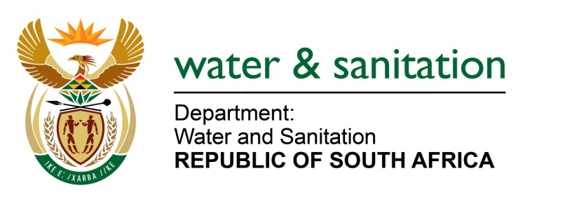

NATIONAL ASSEMBLY

FOR WRITTEN REPLY

QUESTION NO 1548

DATE OF PUBLICATION IN INTERNAL QUESTION PAPER: 29 APRIL 2022
(INTERNAL QUESTION PAPER NO. 15)

1548. Ms P Marais (EFF) to ask the Minister of Water and Sanitation:
By what date will water be provided for the community of Phokwane in Pampierstad, that has been without water for weeks?
NW1872E

---00O00---
MINISTER OF WATER AND SANITATION

The water challenges in Phokwane still persist but the municipality is working on a long-term plan address the matter. The Pampierstad bulk water supply system consists of seven reservoirs. One of these and two pumping stations are currently under construction. Raw water is obtained from the Vaalharts irrigation canal and stored in a 24Ml concreted lined dam, from which it is pumped to two concrete lined dams of 25 Ml at the water treatment works. The capacity of the treatment works is 9.6 Ml/day. Treated water is pumped via two asbestos cement rising mains to the main reservoir. The Phokwane Local municipality is planning to install a 315mm uPVC pipeline to augment the water supply from the treatment works.

The main reservoir site consists of one ground level reservoir of 6.5Ml and a 700-kl concrete tower reservoir. The tower reservoir is not operational as the electrical works required by the pumping station are not in place. Water currently gravitates from the ground level reservoir to the distribution networks of the town and suburbs.

A 400mm diameter uPVC pipeline was recently constructed to supply water from the main reservoir site to a new 10Ml storage reservoir on the hill near the village of Upper Majaekgoro. The reservoir was constructed as part of a bulk water supply upgrade project initiated in 2017/18 with the Municipal Infrastructure Grant (MIG) to the value of R31 433 484.

To address the aforementioned shortcomings, a feasibility study to assess the efficiency and reticulation systems of Pampierstad and surrounding villages in providing its water supply areas with water of acceptable quality and quantity in a sustainable manner, was completed in February 2022 by the Phokwane Local Municipality. An estimated R70 905 356 is required to complete the Pampierstad Bulk Water Supply and is to be allocated via MIG.

It is therefore critical that the tower reservoir of 700kl be re-commissioned. This is necessary to solve the low-pressure problems, as currently experienced in a large area in Pampierstad. It is also required to commission the new 10ML reservoir to meet the water demands.

The Department of Water and Sanitation has invested over R72 million to replace asbestos cement (AC) pipes. The Phokwane local municipality is currently busy with Phase 5 of the project which is funded through MIG.

As an interim measure, the municipality uses the tankering system to fill water tanks that are placed at strategic areas where water provision remains a challenge.

---00O00---

