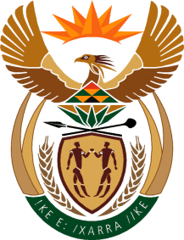

MINISTRY OF TOURISM
REPUBLIC OF SOUTH AFRICA

Private Bag X424, Pretoria, 0001, South Africa. Tel. (+27 12) 444 6780, Fax (+27 12) 444 7027
Private Bag X9154, Cape Town, 8000, South Africa. Tel. (+27 21) 469 5800, Fax: (+27 21) 465 3216

Ref: TM 2/1/1/10

NATIONAL ASSEMBLY:

QUESTION FOR WRITTEN REPLY:
Question Number: 1548
Date of Publication: 2 June 2017
NA IQP Number: 20
Date of reply: 22 June 2017

Mr G R Krumbock (DA) to ask the Minister of Tourism

With reference to above average increases in economic growth by a number of African countries in recent years, what are the reasons for the compound annual growth rate of African tourist arrivals to the country only reaching 1,5% between 2014 and 2016, when the compound annual growth rate of total arrivals to the country was 2,6% for the same period? NW1749E

Reply:
Perception studies and insights activators conducted by SA Tourism in various African markets revealed that the key barrier to travel from the rest of Africa to South Africa is the perception of South Africans being unfriendly and unwelcoming to people from the continent.

Visa processes capacity issues as well as the attacks on foreigner nationals in South Africa negatively impacted the positive image of South Africa.

