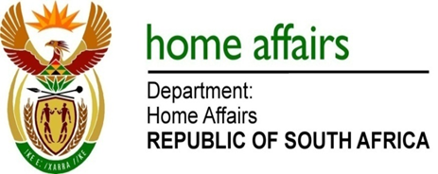

NATIONAL ASSEMBLY

QUESTION FOR WRITTEN REPLY

QUESTION NO. 1547

DATE OF PUBLICATION: Friday, 20 May 2016

INTERNAL QUESTION PAPER 16 OF 2016

1547. Mr T Z Hadebe (DA) to ask the Minister of Home Affairs:

(a) What amount did (i) his department and (ii) each entity reporting to him spend on advertising in the 2015-16 financial year and (b) how much has (i) his department and (ii) each entity reporting to him budgeted for advertising in the 2016-17 financial year? NW1718E

REPLY:

The information is tabulated hereunder:

 | Department of Home Affairs (DHA) Response | DHA Response
 | - Budget spend on Advertising in 2015/16 | - Advertising Budget for 2016/17
(i) | R 10 882 439.95 | R 5 654 000.00
 | Government Printing Works (GPW) Response | GPW Response
(ii) | R 519 812.27 | R 774 000. 00
 | Electoral Commission of South Africa (IEC) response | IEC Response
(ii) | R 58 894 341.54 | R 36 040 255.00

