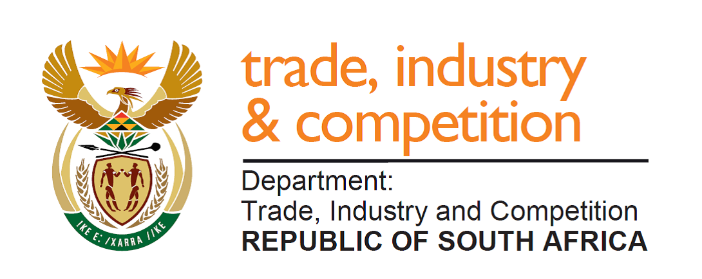

THE NATIONAL ASSEMBLY

QUESTION FOR WRITTEN REPLY

PARLIAMENTARY QUESTION 1546

Mr M J Cuthbert (DA) to ask the Minister of Trade and Industry:
(a) What number of Qualifying Small Enterprises (QSEs) passed broad-based black economic empowerment verification over the past year, (b) how does this compare to the number of companies in the past 10 financial years and (c) what number of QSEs from Level 1 to 8 (i) complied and (ii) did not comply with the verification in the past 10 financial years? NW2871E
Reply
I have been advised by the department as follows:

“A firm with an annual total revenue of between R10 million and R50 million is classified as a Qualifying Small Enterprise (QSE) under the Broad-Based Black Economic Empowerment Act, 2003 (Act 53 of 2003) (the B-BBEE Act).

QSE’s which are majority-owned by black people, do not require verification by a B-BBEE verification professional, and can instead self-certify their status through a standard affidavit. Any misrepresentation in terms of the above constitutes a criminal offence as set out in the B-BBEE Act as amended. A QSE which is 100% owned by black people qualifies automatically for Level 1 B-BBEE status recognition. A QSE which is 51% owned by black people qualifies automatically for Level 2 B-BBEE status recognition.

If 50% or less of an entity’s issued share capital is held by black people, as defined under B-BBEE Act, the entity is required to verify their B-BBEE status using a B-BBEE verification professional.

The B-BBEE Commission became operational in 2016 and one of their functions is to monitor the trends on B-BBEE implementation in the economy. Before the operation of the B-BBEE Commission there was no centralised database which monitor B-BBEE implementation in both the private and public sector. Therefore, the only reliable data on verification for QSEs is for the 2017 and 2018 financial year (Financial year runs from April to March) when the B-BBEE Commission became operational and commenced with the collection of data. This data on QSEs is captured on the B-BBEE Commission’s Portal by the Verification Agencies.

According to the B-BBEE Commission’s National Status and Trends on Broad Based Black Economic Empowerment Report published on 31 March 2019, for the 2018 financial year, there were 588 verified QSEs. QSEs which self-certify are not required to file their status with the B-BBEE Commission and hence are not captured in the Report. There were 851 verified QSEs captured in 2017. The decrease is explained to be largely due to the expansion of the self-certification process for QSEs with 51% or higher ownership by black people.”

The table below provided by the Commission shows the distribution of QSEs by B-BBEE status for those that have been verified by B-BBEE verification professional:

Overall Contribution Levels: QSE Entities
Overall Contributions Levels: QSE Entities B-BBEE Status | Percentage of certificate B-BBEE Level (2018) | Percentage of certificate B-BBEE Level (2017)
Level 1 | 9.69% | 12.74%
Level 2 | 11.05% | 10.33%
Level 3 | 8.33% | 6.43%
Level 4 | 7,48% | 9.64%
Level 5 | 4.42% | 3.21%
Level 6 | 2.72% | 4.36%
Level 7 | 4.76% | 4.94%
Level 8 | 12.76% | 10.91%
Non-Compliant | 38.78% | 37.43%
Grand Total | 100% | 100%

-END-

