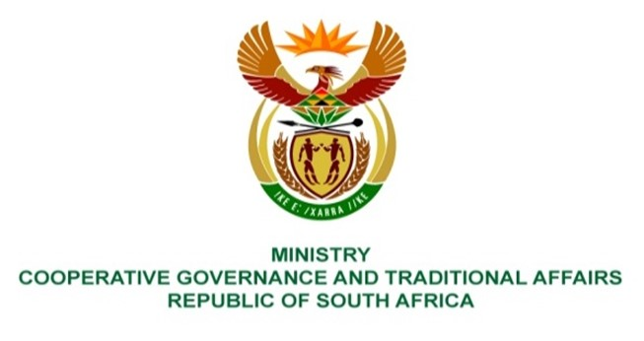

NATIONAL ASSEMBLY
QUESTIONS FOR WRITTEN REPLY

QUESTION NUMBER 2021/1545
DATE OF PUBLICATION: 28 MAY 2021

Ms R N Komane (EFF) to ask the Minister of Cooperative Governance and Traditional Affairs:
Given that the contracts of Community Work Programme implementing agents have been extended with six months, (a) what is the reason that there are delays in the payment of stipends to participants in the specified programme and (b) has she held anyone responsible for the specified delays? NW1748E

REPLY:

1 (a) The delay in payment of several participants for April 2021 was due to the process of re-registration of participants for the 2021/22 financial year as well as 2 days of downtime of the payment system hosted by an external payment provider. Payments to some participants were delayed in the month of May 2021 due to a payment data-file error that resulted in the payment file being rejected by the bank.

1 (b) The department is prioritising the improvement of efficiencies in the entire CWP program, especially ensuring that legitimate participants are paid timeously. The CWP Branch is in the process of reviewing re-registration procedures to ensure that similar delays due to re-registration of participants are not experienced at the commencement of the 2022/23 financial year. A new payment system is currently being developed and will be implemented by 30 September 2021. The new payment system will introduce controls to ensure that payment data files do not contain errors. Interim controls have been put in place on the current system to verify payment data files until the new system has been implemented.

