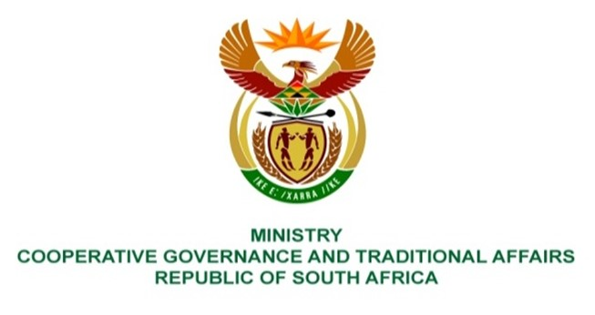

NATIONAL ASSEMBLY
QUESTION FOR WRITTEN REPLY

QUESTION NUMBER 1544
DATE OF PUBLICATION: 29 APRIL 2022

QUESTION:

1544. Mrs M R Mohlala (EFF) to ask the Minister of Cooperative Governance and Traditional Affairs:
What measures have been put in place by her department to ensure that funds allocated by her department to assist families affected by the devastating floods will not be embezzled in the same way COVID-19 funds were? NW1868E
REPLY:
The public finances are governed by legislative prescripts and regulatory frameworks that stipulate the conditions including the roles and responsibilities of all relevant stakeholders. It is therefore important that the accounting officers of organs of state and stakeholders ensure that funds are utilised in accordance with the applicable regulatory frameworks. For the response and recovery measures of the recent flooding, government through relevant organs of state has strengthened the monitoring systems through the following key measures:
- Tracking of expenditure by National Treasury where changes to the fund and project segment have been implemented in the Basic Accounting System (BAS),
- Tracking procurement where all institutions affected by the flood disaster must report to National Treasury all procurement transactions related to flood interventions,
- Real time auditing by the Office of the Auditor-General focussing on the following areas:
Prevention – testing the implementation of the preventative controls and the remaining risks will be reported to the accounting officer/authority,
Detection - high-risk transactions will be subjected to an audit and key observations reported to the accounting officer/authority; and
Reporting on work done by the AGSA, the outcome thereof and the responses by accounting officers and authorities to any weaknesses identified are reported in a special report. The audits are meant to provide independent assurance on whether public funds have been appropriately accounted for and were used for its intended purpose.

