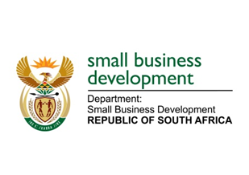
NATIONAL ASSEMBLY
QUESTION FOR WRITTEN REPLY
DUE TO PARLIAMENT: FRIDAY, 11 JUNE 2021

“1544. Mr D F Mthenjane (EFF) to ask the Minister of Small Business Development:
What (a) engagements has she had with small businesses in Cape Town townships in order to understand the full impact of the growing practice of gangs demanding protection fees from small businesses and (b) has she found is the full impact of the specified practice on small businesses?” NW1747E
_________________________________________________________________________________
REPLY:

The Department of Small Business Development (DSBD), through the District Development Model initiative, has held a series of discussion sessions across the Western Cape District Municipalities, engaging SMMEs and Co-operatives on various matters that have an impact on their businesses and also focusing on the interventions that the Department has to offer the small businesses with the view of assisting them financially and non-financially. The Deputy Minister of Small Business Development led some of these engagements, particularly in Cape Town.

The growing practice of gangs demanding protection fee, not only from small businesses but from businesses in general is a serious matter that Government as a whole is acutely aware of and is attending to it with the seriousness it deserves. The DSBD, through the Government Cluster system has supported for the Justice, Crime Prevention and Security (JCPS) Cluster to look into developing a holistic strategy to address this phenomenon; and this is a process that is currently underway. This process will assist in determining the full impact of this specified practice on South African businesses, especially small businesses.

_______________________________________________________________________________
RESPONSE RECOMMENDED BY:

_______________________
MR LINDOKUHLE MKHUMANE
DIRECTOR GENERAL: DEPARTMENT OF SMALL BUSINESS DEVELOPMENT
DATE:

______________________________________________________________________________
RESPONSE RECOMMENDED BY:

________________________
MS ROSEMARY CAPA, MP
DEPUTY MINISTER OF SMALL BUSINESS DEVELOPMENT
DATE:

_______________________________________________________________________________
RESPONSE APPROVED BY:

_________________________
MS KHUMBUDZO NTSHAVHENI, MP
MINISTER OF SMALL BUSINESS DEVELOPMENT
DATE:

